WIPO |  | PCT/MIA/III/2 Add.4  ORIGINAL: English  DATE: June 15, 1993
WORLD INTELLECTUAL PROPERTY ORGANIZATION
GENEVA
International patent cooperation union
(PCT union)
Meeting of international authorities
under the PCT
Third Session
Geneva, June 21 to 25, 1993
OBSERVATIONS AND SUGGESTIONS FOR MODIFICATIONS OF VARIOUS DOCUMENTS RECEIVED FROM INTERNATIONAL AUTHORITIES
Document prepared by the International Bureau
1 Annex to this document complements document PCT/MIA/III/2 Add. 3 and
contains further observations on, and suggestions for, modifications of
various documents relating to international search and international
preliminary examination provided by the European Patent Office.

2 These observations and suggestions are hereby provided to all
International Authorities for information and comments.

[Annex follows]
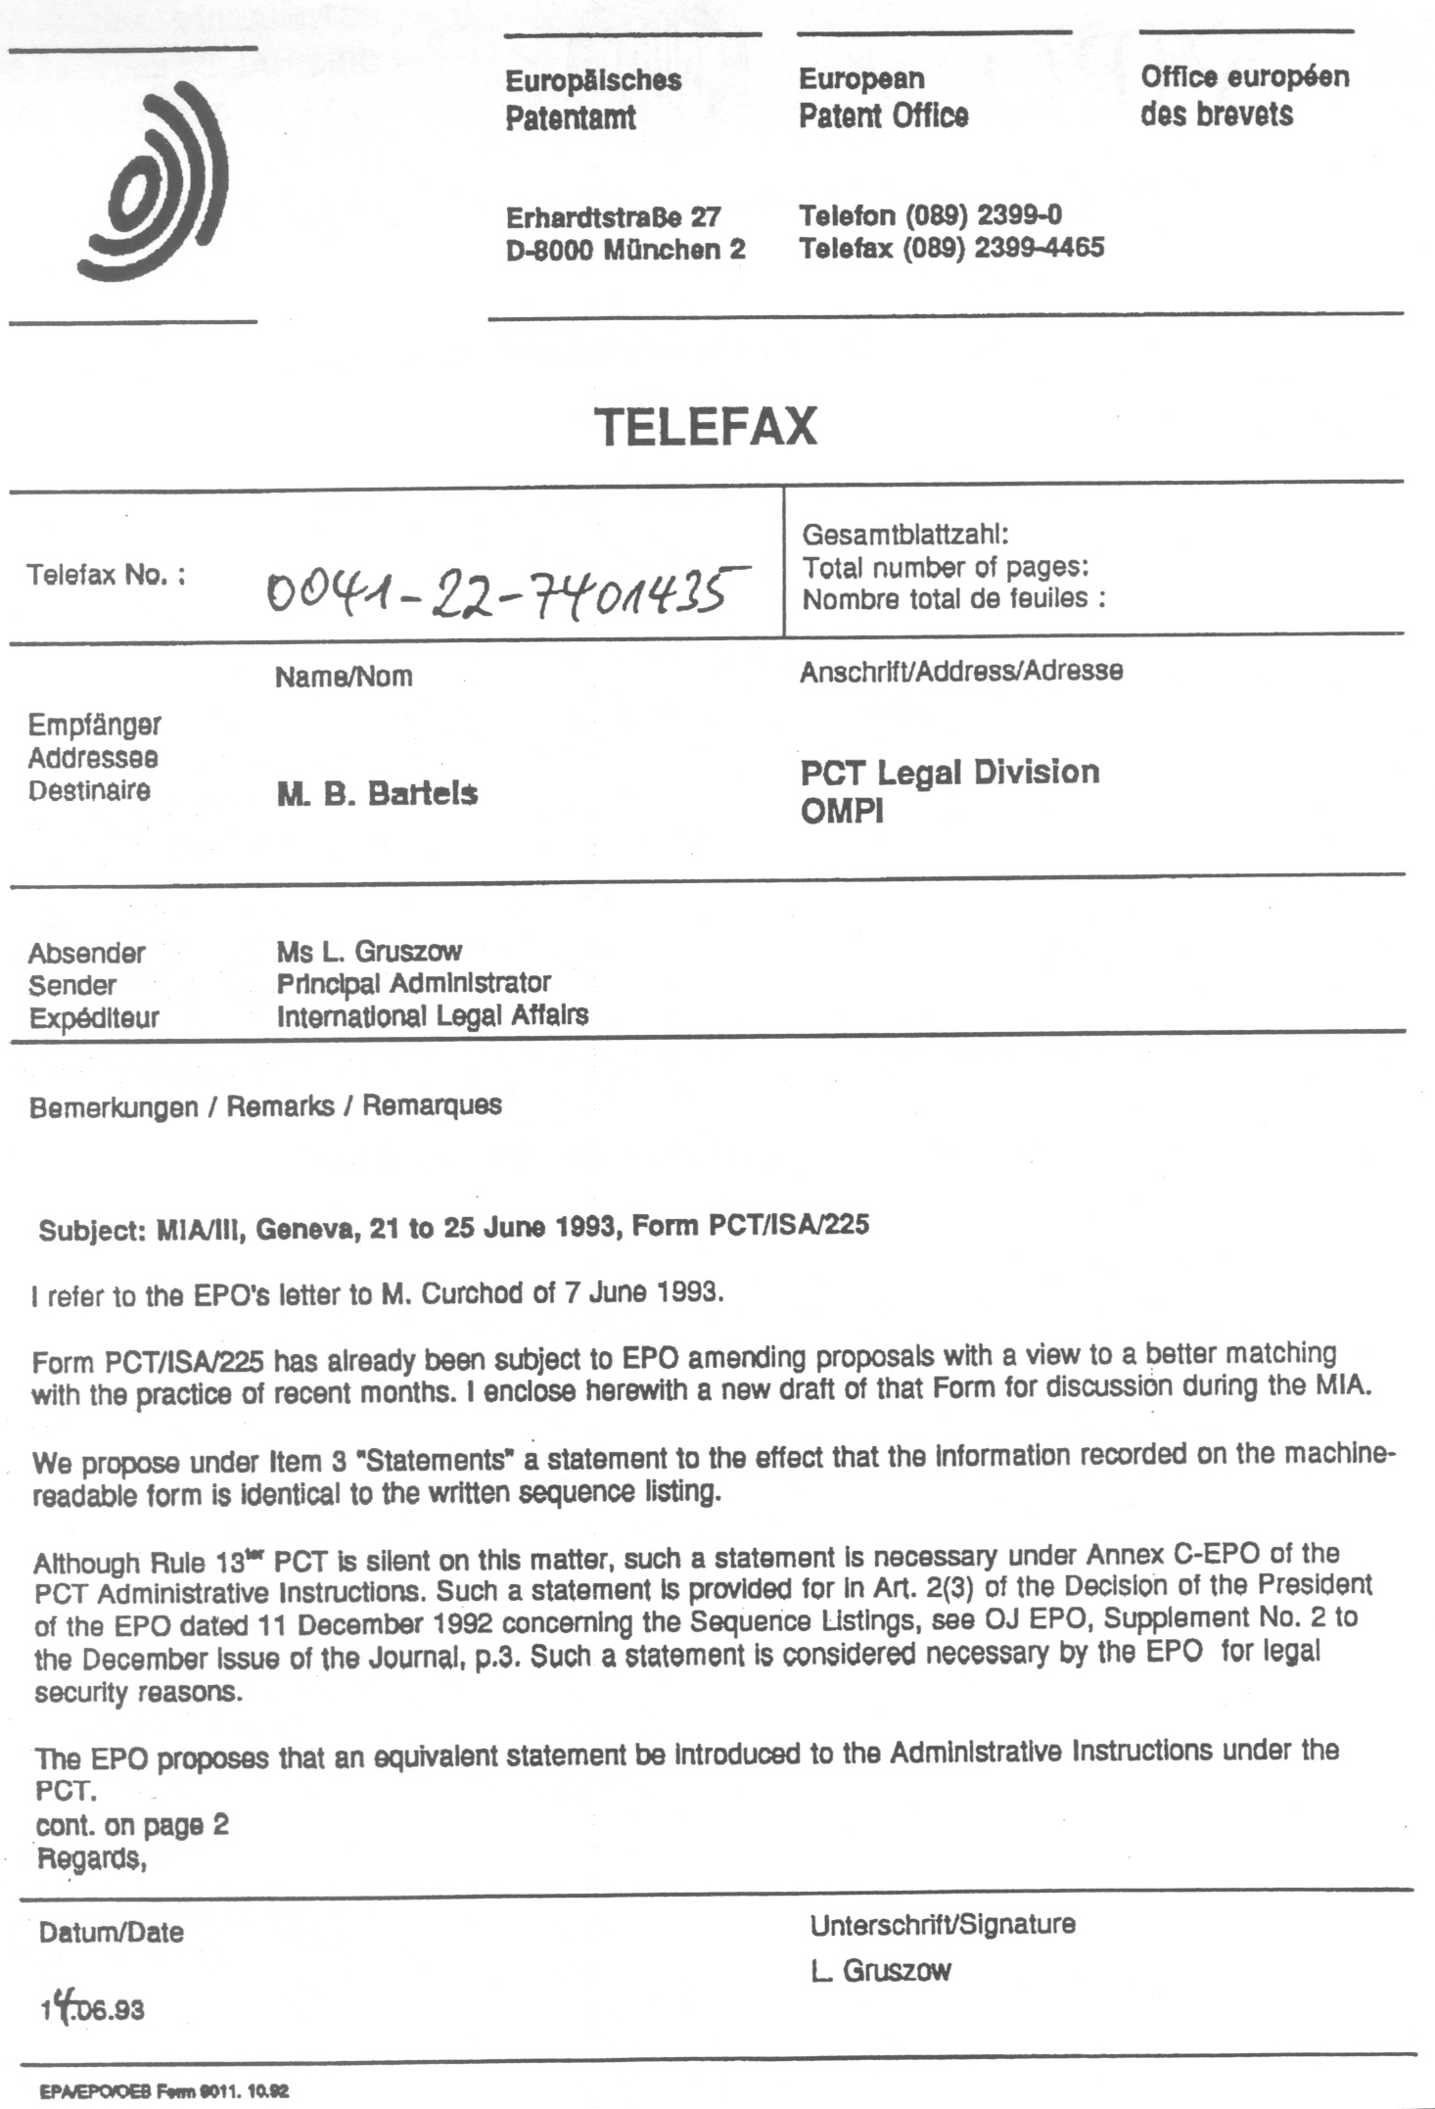

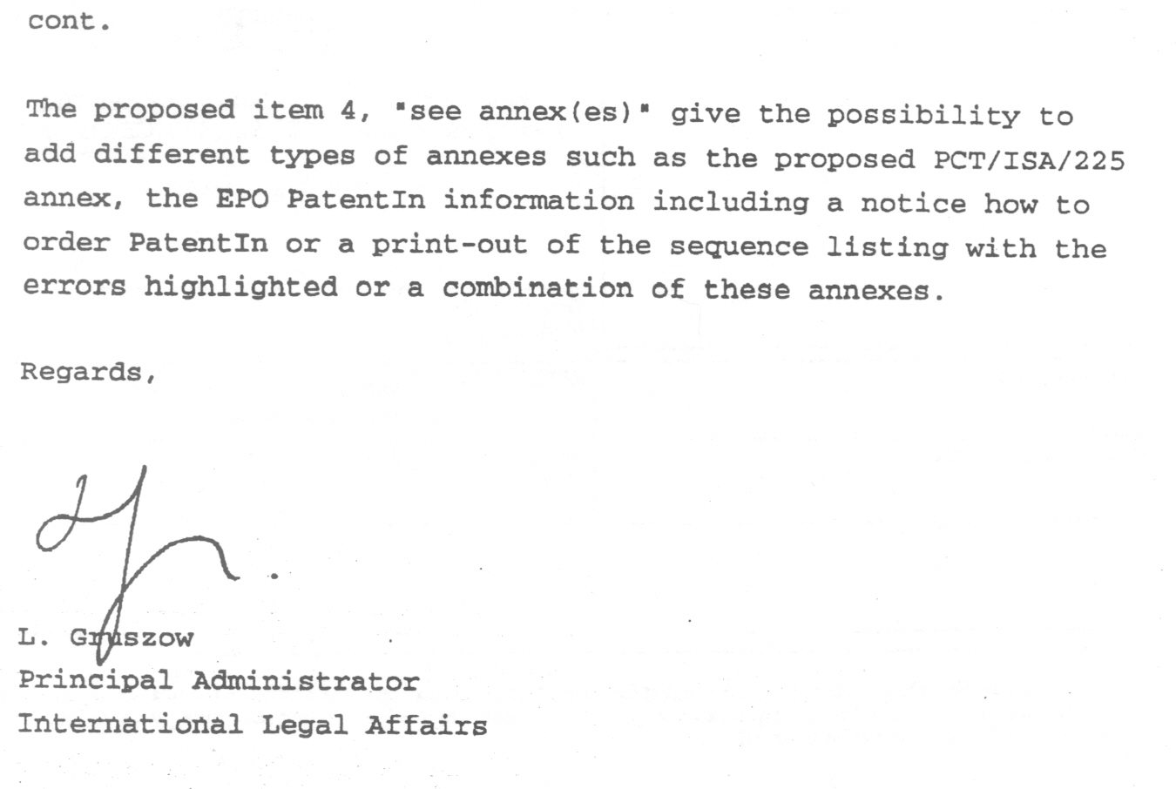
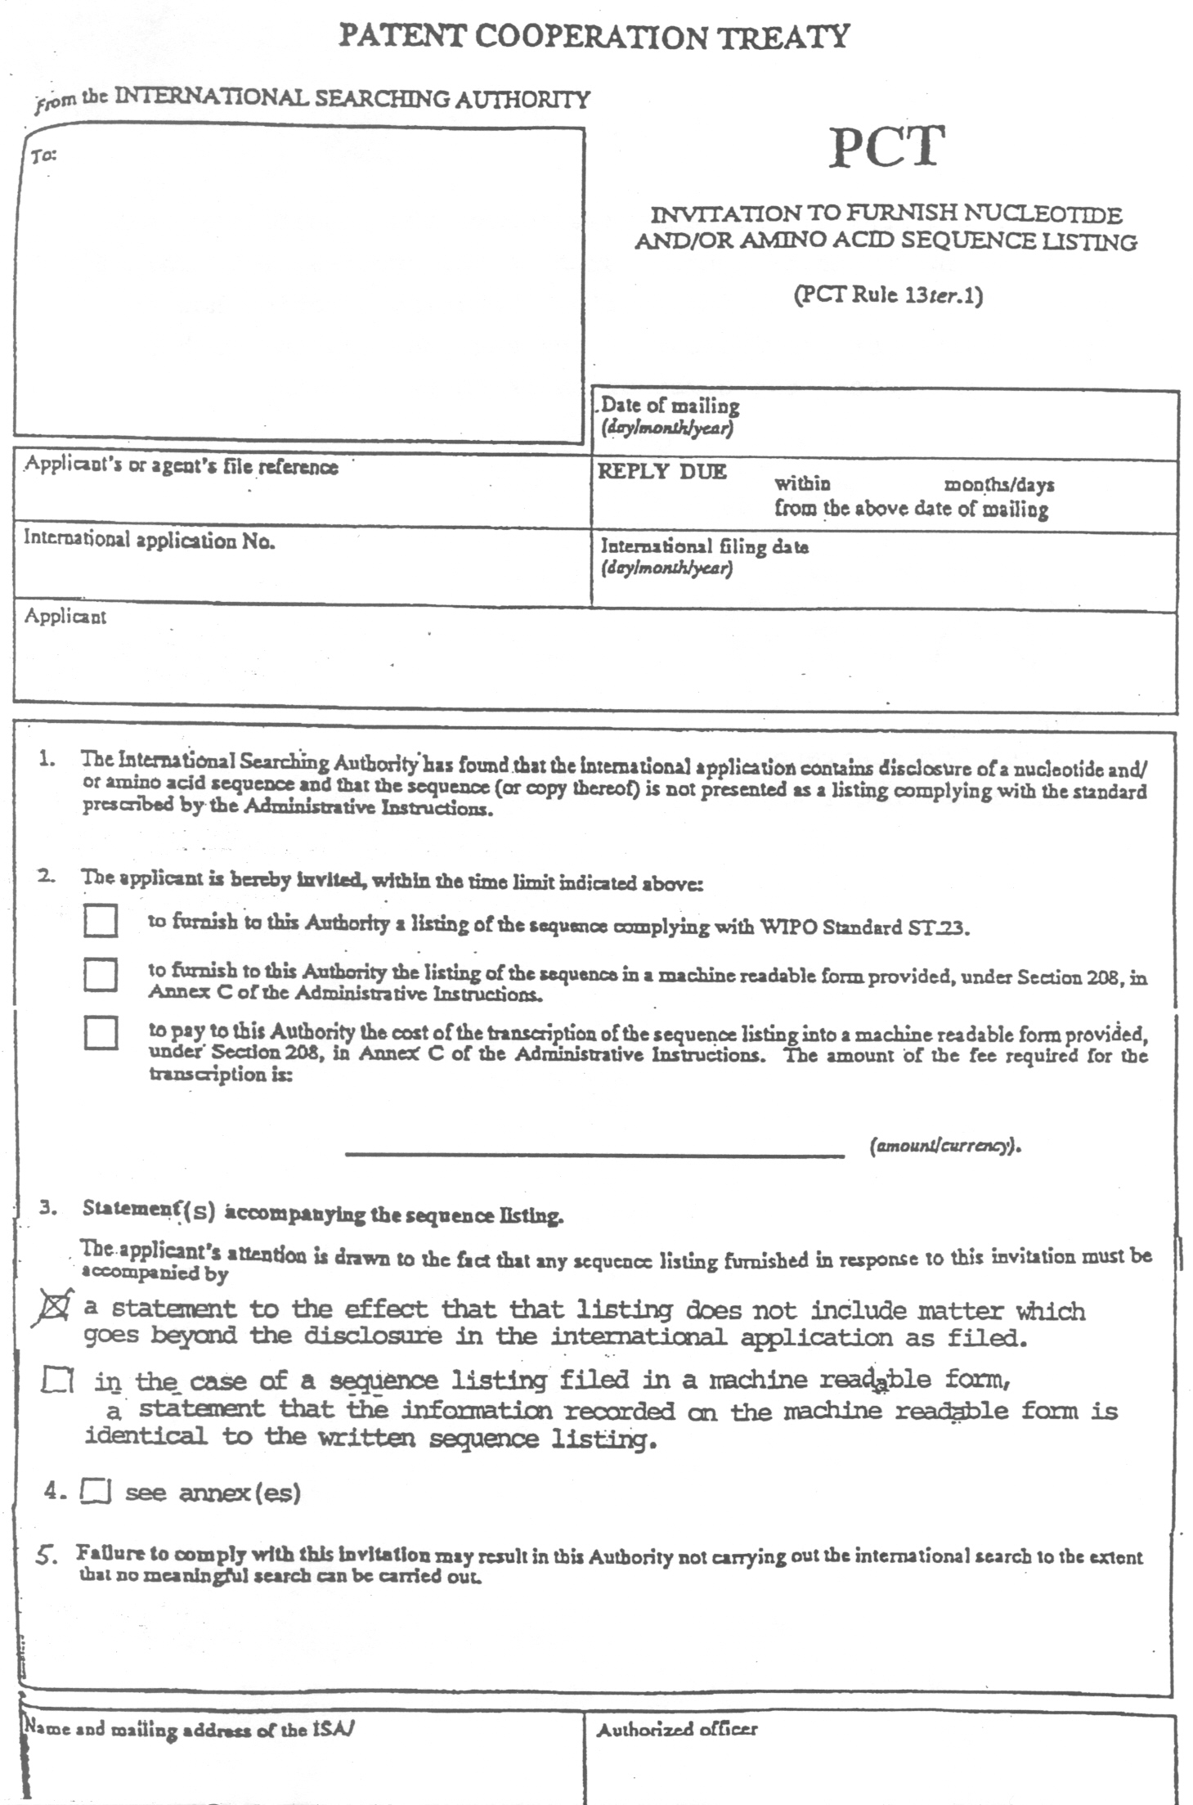

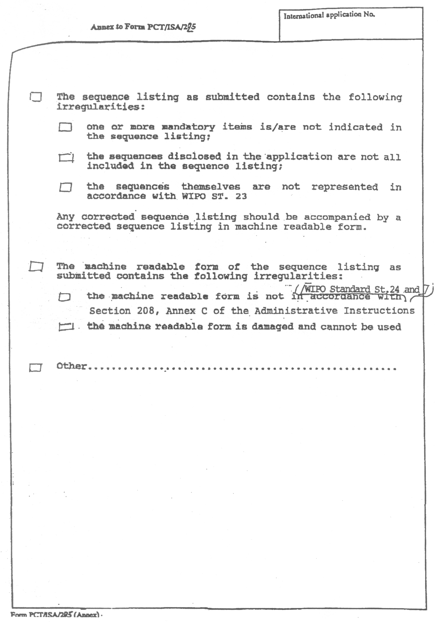
[End of annex and of document]

