E
pct/mia/21/10
ORIGINAL: English only
DATE: January 15, 2014

Meeting of International Authorities
under the Patent Cooperation Treaty (PCT)

Twenty-First Session
Tel Aviv, February 11 to 13, 2014

Options or Consequences when Inviting the Applicant to Select a Competent International Searching Authority after the Chosen International Searching Authority Declares Itself Non-Competent

Document submitted by the United States Patent and Trademark Office

SUMMARY
- The United States Patent and Trademark Office (USPTO) is seeking input from International Authorities and the International Bureau as to (1) if they, in their capacity as a receiving Office, are faced with inviting applicants to select a competent International Searching Authority (ISA) when the originally selected ISA declares itself non-competent and, (2) what consequence or sanction they impose for non-response to such invitation.

Background
- The USPTO in its capacity as a receiving Office (RO/US) under the PCT has an extensive network of competent International Searching Authorities (ISA). Currently, U.S. applicants filing in RO/US or RO/IB may choose the USPTO, the European Patent Office (EPO), the Korean Intellectual Property Office (KIPO), IP Australia or the Federal Service for Intellectual Property of the Russian Federation (Rospatent) as the ISA, with some restrictions. Some of these Offices have limited the extent of their competency for U.S. applicants. For example, the EPO has declared itself non-competent for applications filed by U.S. applicants in RO/US or RO/IB where one or more claims is directed to the field of business methods as defined by certain International Patent Classification units. This limitation as to EPO’s competence is beneficial to U.S. applicants whom might otherwise choose ISA/EP only to learn that the subject matter of their application is considered excluded subject matter under PCT Rule 39 by ISA/EP and therefore not receive a search of one or more claims. Where all the claims are directed to the excluded matter, the applicant would receive a declaration of non-establishment of the international search report.
- The USPTO in its capacity as a receiving Office has experienced an operational issue with this process. When the chosen ISA declares itself non-competent, the RO/US is compelled to invite the applicant to select a new, competent ISA. However, RO/US has found that some applicants are not compelled to respond to such an invitation and does not believe that there is a legal basis for imposing a consequence for non-response. The RO/US generally uses Form PCT/RO/132 and sets a one month period for response. A sample is attached as Annex A.

ISSUE
- The USPTO would like to set the consequence for non-response to the invitation mentioned above as either (1) that the ISA will automatically default to some “primary” ISA as set by the RO, or (2) withdrawal of the application. In either instance, the USPTO is concerned that there is no legal basis in the Treaty or Regulations to do so.

- The Meeting is invited to comment on:
(a) whether or not their Office, in its capacity as a receiving Office, has experienced similar situations to that outlined in paragraph 3, above; and
(b) what consequence for non-response they use or would consider appropriate when inviting an applicant to select a competent International Searching Authority.

[Annex follows]
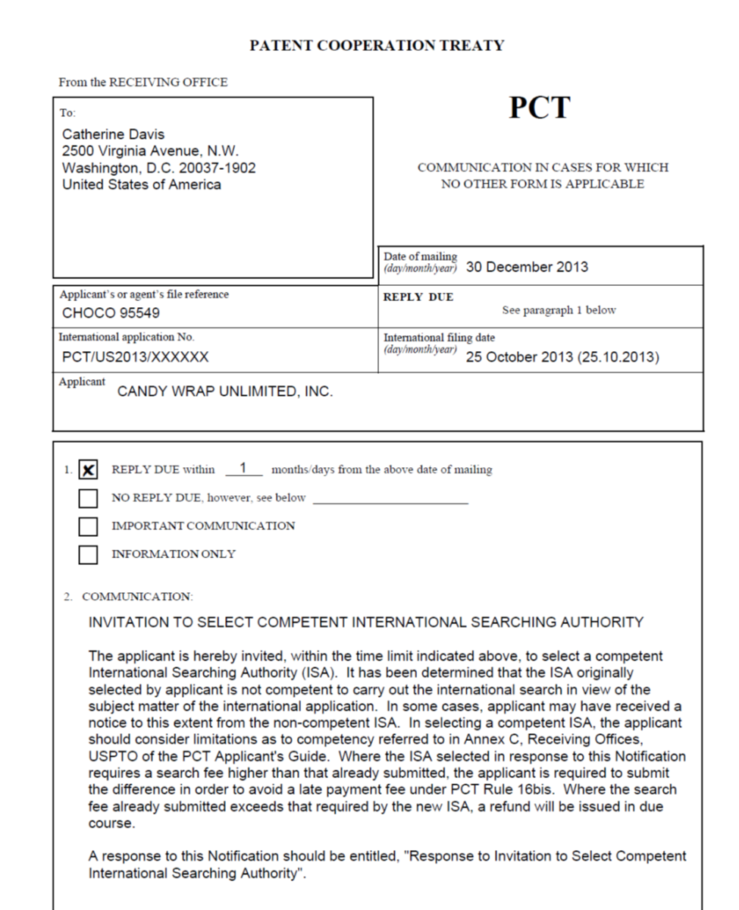

[End of Annex and of document]

See Annex A of the Agreement between the European Patent Organisation and the International Bureau of the WIPO in relation to the functioning of the EPO as an International Searching Authority and International Preliminary Examining Authority under the PCT at http://www.wipo.int/export/sites/www/pct/en/texts/agreements/ag_ep.pdf.

