E
PCT/CTC/30/3
ORIGINAL: English
DATE: March 16, 2017

Patent Cooperation Treaty (PCT)
Committee for Technical Cooperation

Thirtieth Session
Geneva, May 8 to 12, 2017

Extension of Appointment of the Austrian Patent Office as an International Searching and Preliminary Examining Authority Under the PCT

Document prepared by the International Bureau

- All of the existing International Authorities were appointed by the PCT Assembly for a period ending on December 31, 2017. In 2017, the Assembly will therefore need to make a decision on the extension of the appointment of each existing International Authority that wishes to seek an extension of its appointment, having first sought the advice of this Committee (see PCT Articles 16(3)(e) and 32(3)). Information concerning this process and the role of the Committee is set out in document PCT/CTC/30/INF/1.
- On March 6, 2017, the Austrian Patent Office submitted its application to extend its appointment as an International Searching Authority and International Preliminary Examining Authority under the PCT. This application is reproduced in the Annex to this document.
- The Committee is invited to give its advice on this matter.

[Annex follows]
Application of the Austrian Patent Office
for Extension of Appointment
as an International Searching and Preliminary Examining Authority Under the PCT

1 – General
Name of national Office: Austrian Patent Office (APO)

Session of the Assembly at which appointment is to be sought: Forty-ninth session.

The Austrian Patent Office (APO) was established in 1899 as the government body responsible for examining, granting and administrating industrial property rights, now under the Ministry of Transport, Innovation and Technology. From 1978 onwards, the APO has been acting as an International Authority under the PCT. The APO also offers Supplementary Searches under the PCT.

The APO prepares search and examination reports for national and international patent applications in all technical fields. The number of substantial search and examination reports for patents and utility model prepared by the APO in 2016 was more than 3500.

The Austrian Patent Office has been appointed as ISA/IPEA during the first session of the PCT Assembly in 1978 and currently acts as ISA/IPEA/SISA for applications from 37 different Receiving Offices. The number of PCT-Searches and Examination Reports is now around 200 per year.

2 – SUBSTANTIVE CRITERIA: MINIMUM REQUIREMENTS FOR isa/IPEA
As described below, the Austrian Patent Office meets the minimum requirements which are demanded in Rule 36.1(i) to 36.1(v) for reappointment as an International Searching Authority, and Rule 63.1(i) to 63.1(v) for reappointment as an International Preliminary Examination Authority.

2.1 – Search and Examination Capacity
Rule 36.1(i) [63.1(i) for IPEA] the national Office or intergovernmental organization must have at least 100 full-time employees with sufficient technical qualifications to carry out searches [examinations].
Employees qualified to carry out search and examination:
The APO has a staff of around 100 full-time employees with sufficient technical skills to conduct searches. The employment requirements (university degree, at least equivalent to Master's degree) guarantee the technical qualification for the search and examination in all technical areas. The examiners have access to translation tools via the Internet and EPOQUENet.
Technical field | Number (in full-time equivalent)
Constuction / Physics | 21
Mechanical | 27
Electrical/electronic | 29
Chemistry / Biotech | 24
Total | 101

New employees have to complete a training program which covers 2-4 years, whereby the training consists of close supervision by an experienced examiner as well as a teaching program followed by written and oral exam. After this training phase and this exam, the examiner becomes fully competent and works with minimal supervision. Search and examination is then expected to be carried out according to the PCT guidelines and also under national law.

Examiners in training also act as recording clerks in nullity proceedings. This makes them familiar with the exact assessment of a patent. Examiners after passing their exam get an important additional qualification through active participation in the opposition- and nullity senates. The experience gained in this context has a significantly positive effect on the understanding of the procedure during the search and examination activities.

Examiners also participate in EPOQUENet and other training courses offered by EPO, as well as seminars and other on-line training activities regarding search and examination, organized by EPO and WIPO. In addition, training activities involve the sharing of experience and best practice in search and examination between patent offices.

During the permanent training and development activities the examiners acquire an awareness of the importance of complying with the quality criteria and standards.
For more details please refer to our PCT International Authority Quality Reports since 2006 published on http://www.wipo.int/pct/en/quality/authorities.html.

As a result, APO meets the requirement set out in PCT Rules 36.1(i) and 63.1(i).

Rule 36.1(ii) [63.1(ii) for IPEA] that Office or organization must have in its possession, or have access to, at least the minimum documentation referred to in Rule 34, properly arranged for search [examination] purposes, on paper, in microform or stored on electronic media.
Access to the minimum documentation for search purposes:
A computer aided search and examination process has been established. Each examiner has access to EPOQUENet, to the internet and to a plurality of other databases. This gives the examiners many possibilities for enhancing and completing their State of the Art search beside the search in the PCT minimum documentation.

In addition extensive documentation on paper, microfiche and CD-ROMs provided from many countries is available and managed by the library of the Austrian Patent Office.

For more details please refer to our PCT International Authority Quality Reports since 2006 published on http://www.wipo.int/pct/en/quality/authorities.html

As a result, Austrian Patent Office meets the requirement set out in PCT Rules 36.1(ii) and 63.1(ii).

Rule 36.1(iii) [63.1(iii) for IPEA] that Office or organization must have a staff which is capable of searching [examination] the required technical fields and which has the language facilities to understand at least those languages in which the minimum documentation referred to in Rule 34 is written or is translated.

In addition to the main working language German, also English and basic French skills are one of the conditions for recruitment of new staff. Language training for English and French is offered to the examiners to constantly improve their skills in these languages.
Language(s) in which national applications may be filed and processed:
National applications can be filed in German, English or French. If the application is not in German, the applicant receives a first written opinion including search results based on this English or French version. To further continue his application, the applicant has to file a translation of the complete application in German.

The examiners of the APO use translation tools in EPOQUENet and other databases.

Therefore, APO meets the requirements set out in the PCT Rules 36.1(iii) and 63.1(iii).

2.2 – Quality Management
Rule 36.1(iv) [63.1(iv) for IPEA] that Office or organization must have in place a quality management system and internal review arrangements in accordance with the common rules of international search [preliminary examination]

For details please refer to our PCT International Authority Quality Reports since 2006 published on http://www.wipo.int/pct/en/quality/authorities.html.

With its Quality Management System (QMS), the APO continually improves its performance according to the QMS requirements and is able to review the effectiveness of its QMS.

The management of the APO can identify and promptly take corrective action to eliminate the cause of any failure to comply with the QMS requirements and the PCT Search and Examination Guidelines.

Since 2015 the APO also uses the CAF (Common Assessment Framework) to assess the quality of the Austrian Patent Office. “The Common Assessment Framework (CAF) is the common European quality management instrument for the public sector. For more about CAF please refer to the Website of the CAF Center EU http://www.caf-zentrum.at/de/CAF-Center-EU.

As a result, APO meets the requirement set out in PCT Rules 36.1(iv) and 63.1(iv).

3 – Assessment by other Authorities
Existing ISA/IPEA(s) assisting in assessment of extent to which criteria met:
A formal assessment of the Office by other International Authorities is not expected in the context of extension of an existing appointment. However, the Office is keen to work with other Authorities and receive feedback to improve its services. In this context, it participated in the “paired review” pilot exercise in the meeting of the Quality Subgroup held in the context of the twenty-fourth session of the Meeting of International Authorities Under the PCT (see paragraphs 9 to 12 of document PCT/MIA/24/15) and intends to participate in similar exercises in the future.

Furthermore in 2016 two professionals at INAPI’s Patent Division from Chile visited the APO to share experience in view of continuously improving the quality of work of both offices in their PCT role.

4 – Statement of Motivation
The Austrian Patent Office (APO) was established in 1899 as the government body responsible for examining, granting and administrating industrial property rights. As of 1978 we act as an International Authority under the PCT.

(i) APO acts as ISA/IPEA/SISA for 37 different Receiving Offices. The regulation limits the ability of the Austrian Patent Office to conclude ISA/IPEA agreements to the Offices from developing countries only, which sometimes forces us to refuse new agreements. In our work as an International Authority, we are happy to share our long-term (more than 100 years) experience in granting national patents as well as providing search and examination, with offices and applicants from other countries, with the focus on the developing states. Most of the applicants can benefit from a special discount on the standard search fee for natural persons. For applicants not eligible for this discount, the search fee can be partially refunded, provided that we can benefit from an earlier search. For details please see the PCT Applicants guide http://www.wipo.int/pct/guide/en/gdvol1/annexes/annexd/ax_d_at.pdf.

Together with WIPO we organize a yearly training course for examiners of the other offices. Following the special request of the participants, we put a special emphasis on database search.

Our office also actively participates in the Global PPH, which includes PCT-PPH (see the Patent Prosecution Highway Portal Site: http://www.jpo.go.jp/ppph-portal/index.htm). This enables applicants using APO as ISA or as Office of First Filing to request accelerated examination for subsequent filings in more than twenty offices.

(ii) Moreover, being an International Authority under the PCT allows the Austrian Patent Office to actively participate in the rapid evolution of the PCT. APO benefits from its status as ISA/IPEA/SISA as it is in regular contact and lively exchange of knowledge with other most developed patent offices. In this capacity APO takes part in the advancement and harmonization of the search and examination process. Being an International Authority means being strongly committed to the highest international search and examination standards and to constantly keeping our services and processes up to the state of art. This not only raises the self-esteem of our staff members but is also our “calling card” for the national and international innovation community.

(iii) Altogether, the Austrian Patent Office has been a reliable and a flexible partner in the PCT system for more than 30 years now.

We had a chance to prove our flexibility in the course of implementing and testing new systems. In cooperation with WIPO we are also happy to contribute to the development of new systems such as ePCT or eSearchCopy for both of which we are early adopters and intensive users. We are now receiving eSearchCopies from currently 10 (out of the 37) Receiving Offices for which we act as ISA. We are proud being one of the offices with the most active use of ePCT for communication with applicants, with WIPO and with the other offices – both in our capacity as a Receiving Office (RO) and as ISA/IPEA. We are currently in the course of completely replacing our old database by ePCT.

We are looking very much forward to widely sharing our respective experience, since we are convinced that the ePCT and eSearchCopy systems are a better alternative for the applicants, for the offices and therefore, for the whole of the PCT system.

We would be honoured to continue our contribution to the essential work of the PCT as one of its International Authorities.

5 – Applicant State(s)
Austria is a federal republic state with a parliamentary democracy in Central Europe. The federal legislation is exercised by the national council (Nationalrat) together with the Upper House of Parliament (Bundesrat) – the two chambers of Parliament. Austria is a member of the European Union, the United Nations as well as most UN organizations.
Of the approximately 8 million inhabitants of Austria, 98 per cent speak German. The six ethnic groups officially recognized in Austria (Burgenlandic Croatians, Roma, Slovaks, Slovenians, Czechs and Hungarians) are concentrated in the east and south of the country.

After starting a new year with the famous “Neujahrskonzert”, now broadcasted in over 90 countries, Austrians contribute to a strong economy with machinery, metallurgical products and textiles being of particular importance. The country's most important industry however is tourism.

Austria has for more than 100 years a well-functioning IP system with modern legislation, administrative body, institutionalized attorney system and other stakeholders. According to the IP indicators published by WIPO, in 2015 Austria ranked 18th in trademark (97.027) and 16th in patent filings (13.925) by residents.

For a “touristic” overview on Austria please visit http://www.austria.info/uk, an overview on the Austrian economy is given here: http://www.austria-export.biz/en/.
Regional location

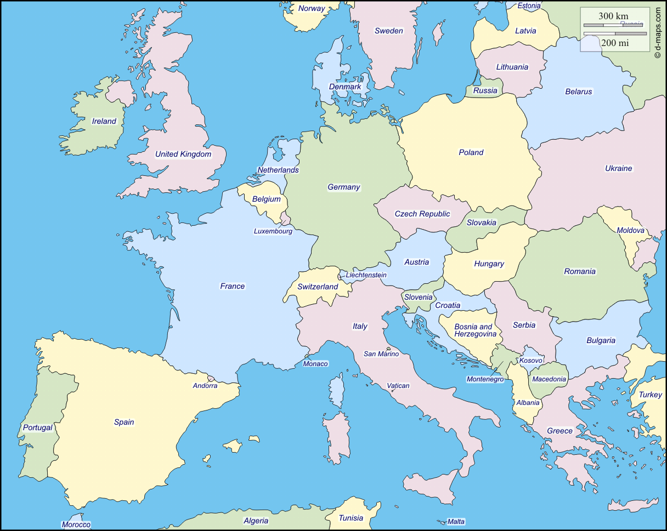
Map showing State and neighbouring States

5.1 Regional organisation memberships:
Austria is a member of the United Nations as well as most UN organizations. Since 1995 Austria is a member of the European Union.

Since April 1979 Austria is a contracting state of the PCT and since May 1979, a member of the European Patent Organization.
5.2 Population:
2015 8,629,519 (Source: Statistik Austria)
5.3 GDP per capita:
2015 39.390.- euros (Source: Statistik Austria)
5.4 Estimated national R&D expenditure (% of GDP):
2015 3.10 per cent (Source: Statistik Austria)
Source: Statistik Austria http://www.statistik.at/web_en/statistics/index.html

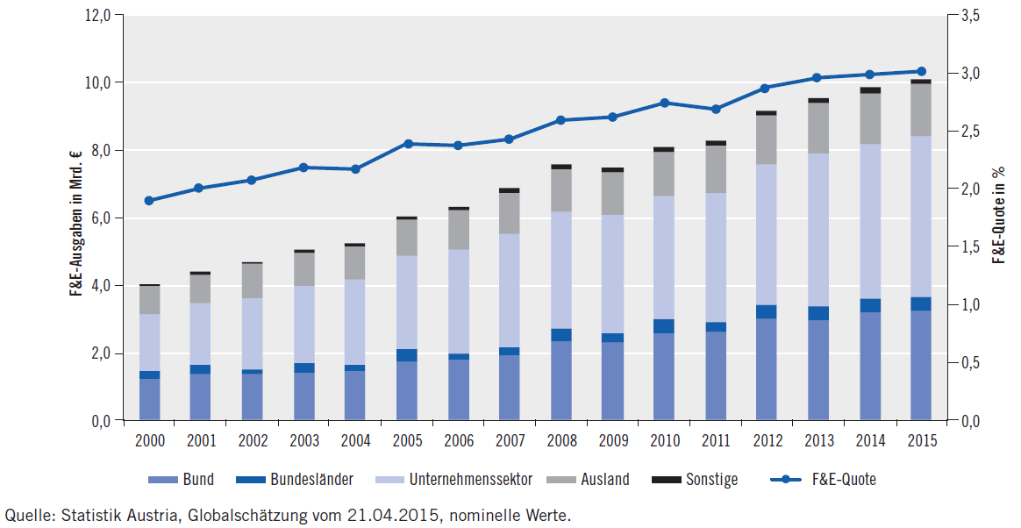

5.5 Number of research universities:
2013 University units with R & D: 1,273 (Source: Statistik Austria)
5.6 Summary of national patent information network (for example patent libraries, technology and innovation support centers):
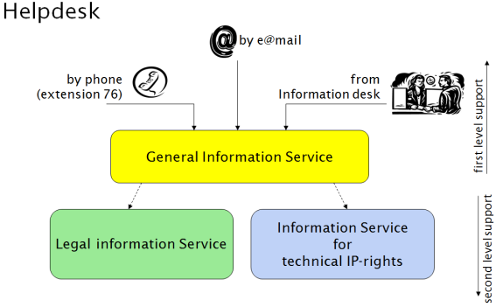
The APO as one of the national PatLib Centers runs a helpdesk for customers.
The APO also supports small and medium-sized enterprises SMEs through a consulting service, which is carried out jointly with an economic agency (discover.IP). In addition, search and examination services are offered for inventions. Special trainings and searches are available for students. Regular lectures in-house and in the regions expand the range of information.

Beside APO there are 5 other PatLib Centers in Austria. In addition, all Regional Chambers of Commerce and their sub-organizations are advising in IP rights. They inform about funding for the implementation of innovations.
5.7 Major local industries:
Austria is a highly developed industrialized country with an important service sector. The most important industries are food and luxury commodities, mechanical engineering and steel construction, chemicals, textiles and vehicle manufacturing.

Austria's industrial and commercial sectors are characterized by a high proportion of medium-sized companies. Austrian industry covers every branch of manufacturing, from basic goods to the labor-intensive production of highly processed products. The construction of plants and systems (encompassing the planning, delivery, and assembly of turn-key production facilities, including the required know-how and operational expertise) is making up an increasingly important share. This field is strongly export-oriented, as is the electronics sector (including, for instance, the production of integrated circuits).

For current economic statistics please visit the website of Statistik Austria:
http://www.statistik.at/web_en
5.8 Major trading partner States:
Import 2015 |  | Export 2015
State | in % | State | in %
Germany | 36.9 | Germany | 30
Italy | 6.1 | United States | 6.9
China | 6 | Italy | 6.3
Switzerland | 5.6 | Switzerland | 5.4
Czechia | 4.2 | France | 4.5
United States | 3.9 | Czechia | 3.6
France | 2.7 | Hungary | 3.3
Netherlands | 2.6 | United Kingdom | 3.2
Hungary | 2.6 | Poland | 3.2
Poland | 2.2 | China | 2.5
Slovakia | 2.2 | Slovakia | 2.1
United Kingdom | 1.8 | Slovenia | 2.1

5.9 Other key information:
A new IP strategy is currently being developed and is expected to be adopted by the Federal Government in February. The APO will host an “IP hub” and coordinate the activities of the different players in IP. For more please refer to
http://archiv.bundeskanzleramt.at/DocView.axd?CobId=65314

The Austrian strategy for “Research, Technology and Innovation” can be downloaded (in German) https://www.bmvit.gv.at/service/publikationen/innovation/forschungspolitik/downloads/fti_strategie.pdf

The strategy for “Open Innovation Strategy for Austria” can be downloaded https://www.bmvit.gv.at/en/innovation/downloads/open_innovation_strategy_for_austria.pdf

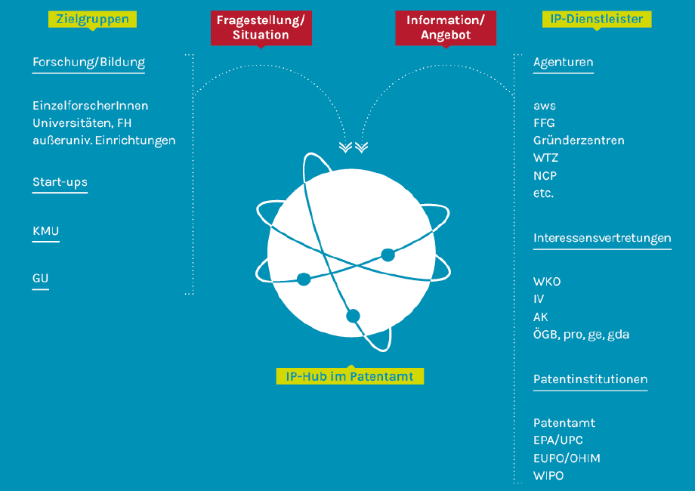
Source: IP strategy http://archiv.bundeskanzleramt.at/DocView.axd?CobId=65314

6 – Profile of Patent Applications
Number of national applications received
 | 2012 | 2013 | 2014 | 2015
Patent | 2,552 | 2,406 | 2,363 | 2,441
Utility model | 711 | 763 | 748 | 754

Number of national patents / utility model grant
 | 2012 | 2013 | 2014 | 2015
Patent | 1,439 | 1,256 | 962 | 1,356
Utility model | 686 | 582 | 488 | 604

Number of national patents grant - by technical field
Technical Field | 2012 | 2013 | 2014 | 2015
1 - Electrical machinery, apparatus, energy | 80 | 81 | 80 | 122
2 - Audio-visual technology | 23 | 19 | 12 | 17
3 - Telecommunications | 6 | 7 | 6 | 8
4 - Digital communication | 6 | 8 | 3 | 4
5 - Basic communication processes | 4 | 3 | 1 | 2
6 - Computer technology | 15 | 19 | 7 | 14
7 - IT methods for management | 1 | 1 | 3 | 2
8 - Semiconductors | 9 | 11 | 8 | 10
9 - Optics | 13 | 6 | 9 | 16
10 - Measurement | 83 | 58 | 43 | 81
11 - Analysis of biological materials | 1 | 2 | 2 | 5
12 - Control | 25 | 18 | 19 | 26
13 - Medical technology | 51 | 45 | 33 | 42
14 - Organic fine chemistry | 5 | 6 | 4 | 3
15 - Biotechnology | 7 | 4 | 2 | 3
16 - Pharmaceuticals | 13 | 6 | 4 | 3
17 - Macromolecular chemistry, polymers | 9 | 4 | 6 | 4
18 - Food chemistry | 10 | 5 | 9 | 11
19 - Basic materials chemistry | 26 | 15 | 7 | 15
20 - Materials, metallurgy | 34 | 35 | 16 | 17
21 - Surface technology, coating | 18 | 22 | 15 | 29
22 - Micro-structural and nano-technology | 1 |  |  | 1
23 - Chemical engineering | 29 | 29 | 28 | 38
24 - Environmental technology | 26 | 29 | 22 | 19
25 - Handling | 69 | 58 | 39 | 62
26 - Machine tools | 100 | 73 | 71 | 86
27 - Engines, pumps, turbines | 87 | 88 | 67 | 58
28 - Textile and paper machines | 41 | 44 | 28 | 47
29 - Other special machines | 93 | 70 | 84 | 138
30 - Thermal processes and apparatus | 79 | 58 | 39 | 56
31 - Mechanical elements | 75 | 86 | 47 | 54
32 - Transport | 81 | 79 | 69 | 102
33 - Furniture, games | 105 | 81 | 49 | 75
34 - Other consumer goods | 38 | 45 | 22 | 44
35 - Civil engineering | 189 | 157 | 119 | 157

Number of national applications received – by route
Route | 2012 | 2013 | 2014 | 2015
Patent - National first filing + Paris priority | 2,002 | 1,873 | 1,901 | 1,954
Patent - PCT national phase entry | 550 | 533 | 462 | 487
Utility model - National first filing/internal priority | 694 | 741 | 724 | 713
Utility model - PCT national phase entry | 17 | 22 | 24 | 41

Number of international applications received
Austrian Patent Office as | 2012 | 2013 | 2014 | 2015 | 2016
RO - Receiving Office | 535 | 473 | 539 | 492 | 507
ISA / IPEA / SISA | 197 | 233 | 234 | 205 | 215
SISA: Supplementary International Search Authority
Number of international Search Reports established by ISA/AT
 | 2012 | 2013 | 2014 | 2015 | 2016
ISA – Search Reports | 392 | 269 | 206 | 204 | 209

Since 2012 applicants from 29 countries have chosen ISA/AT. The top ten countries have been Algeria, Bahrain, Brazil, Colombia, Egypt, India, Republic of Korea, Singapore, South Africa and United Arab Emirates (alphabetic order).

Source: WIPO IP statistics at a glance http://ipstats.wipo.int/ipstatv2/index.htm?tab=patent
Intellectual property right: PCT; Year range: 2010 – 2017; Reporting type: Yearly statistics;
Indicator: 8a - International Searching Authorities (ISA) selected by applicants

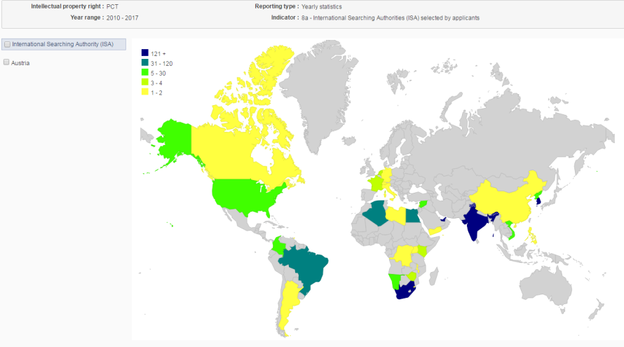

Main Offices/States in which priority is claimed from national applications:
The main Offices/States in which Austrian priority has been claimed since 2000 are the European Patent Office and PCT, followed by Australia, Argentina, Brazil, Canada, China, Croatia, Cyprus, Czech Republic, Denmark, Eurasian Patent Organization, Finland, France, Germany, Hungary, Italy, Japan, Mexico, New Zealand, Norway, Poland, Republic of Korea, Russian Federation, Serbia, Slovakia, Slovenia, South Africa, Spain, Switzerland, Taiwan, Ukraine, United Kingdom and the United States of America (alphabetic order).

Source: Patstat

As our office actively participates in the Global PPH, which includes PCT-PPH, applicants using APO as Office of First Filing or as ISA are enabled to request accelerated examination for subsequent filings in more than twenty offices.
Average time taken for national patent processing
Indicator | Measured from | Time (months)
To search | Internal database | 7.9
To first examination | Internal database | 7.9
To grant | Internal database | 18.5

According to the Austrian Patent Law, a Patent application implicitly includes a request for Search and Examination, without the need of a further request or fee. This means the Austrian patent prosecution process is similar to the PCT process, insofar as the first office action includes a Search Report and a Written Opinion.
National backlogs
Measure | Number of applications
All pending applications | 4,900
Applications awaiting search (where relevant fees paid) | 1,400
Applications awaiting first examination (where relevant fees paid) | 1,400

7 – Other
Please do not hesitate in case of further question to contact
Katharina Fastenbauer
Head of Patent Support and PCT
Deputy Vice-President for Technical Affairs

Austrian Patent Office
Dresdnerstraße 87
1200 Wien
Austria

Tel. +43 1 53 424 447 ; Fax. +43 1 53 424 535
Katharina.Fastenbauer@patentamt.at

[End of Annex and of document]

