E
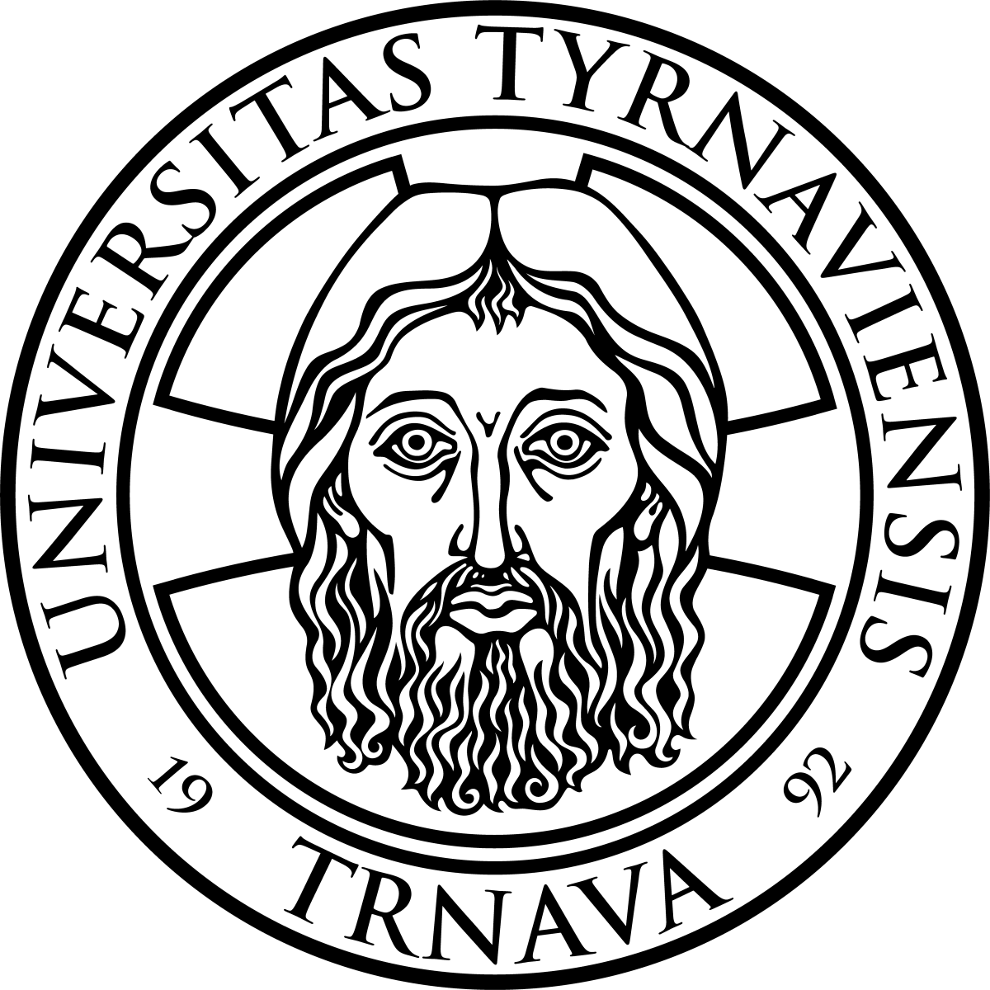
trnava university
NATIONAL WORKSHOP
WIPO/IP/UNI/LTRZ/14/INF/1
ORIGINAL: English
DATE: September 2014

Intellectual Property Policies in Universities and Research Institutions

organized by
the World Intellectual Property Organization (WIPO)

in cooperation with
the Industrial Property Office of the Slovak Republic

and
Trnava University

Trnava, Slovakia, November 13, 2014

PROGRAM

prepared by the International Bureau of WIPO

Thursday, November 13, 2014

8.30 – 9.00 Registration, Morning Coffee

09.00 – 09.15 OPENING CEREMONY

Welcome addresses by:
– Mr. Tomáš Klinka, Head, President’s Office and International Affairs, Industrial Property Office of the Slovak Republic, Banská Bystrica, Slovakia
– Mr. Marek Šmid, Rector, Trnava University, Trnava, Slovakia
– Ms. Monika Ziková, Program Officer, Department for Transition and Developed Countries, World Intellectual Property Organization (WIPO), Geneva

9.15 – 9.45 Topic 1 Importance of Intellectual Property (IP) in Countries in Transition and Relevant WIPO Tools

Speaker: Ms. Monika Ziková

9.45 – 10.15 Topic 2 System of Intellectual Property Protection in Slovakia and Abroad

Speaker: Mr. Tomáš Klinka

10.15 – 10.45 Topic 3 Creation of an IP Culture at Universities and Advantages of Universities having an IP Culture

Speaker: JUDr. Zuzana Adamová, PhD., Director, Intellectual Property Law Institute, Law Faculty, Trnava University, Trnava, Slovakia

10.45 – 11.00 Coffee Break

11.00 – 1.30 p.m. Topic 4 Strategic Use of Industrial Property Rights at Universities

Speakers: Ms. Lenka Midriaková, Attorney, Legal Services and Dispute Development Department, Industrial Property Office of the Slovak Republic, Banská Bystrica, Slovakia

Mr. Miroslav Kubiš, Head, Technology Transfer Centre, Slovak Centre of Scientific and Technical Information, Bratislava, Slovakia

1.30 p.m. – 2.00 p.m. Topic 5 Case Study – Model of IP Policy for Universities and Research Institutions

Speaker: Ms. Monika Ziková

2.00 p.m. – 2.30 p.m. Coffee Break

2.30 p.m. – 4.30 p.m. Topic 6 Roundtable on the Development of IP Policies at Slovak Universities

Moderator: Ms. Monika Ziková

Speakers: Each University / Academy from the Region – representative makes a presentation around 4 – 6 minutes about the situation in her/his University/Academy/Institution or Enterprise to be confirmed

4.30 p.m. – 5.00 p.m. Topic 7 Conclusion and Future Work

Speakers: Ms. Monika Zikova

Mr. Tomás Klinka

5.00 p.m. CLOSING CEREMONY

[End of document]

