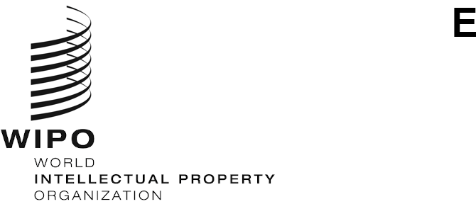
WIPO/IP/CONV/GE/21/INF/1/PROV.3
ORIGINAL: English
DATE: September 13, 2021

WIPO CONVERSATION ON INTELLECTUAL PROPERTY (IP) AND Frontier Technologies

Fourth Session
Geneva, 22 to 23 September 2021, 12.00 to 14.30 CET

Provisional Agenda
prepared by the WIPO Secretariat

Wednesday, September 22, 2021
12.00 – 12.10 Opening
Mr. Daren Tang, Director General, World Intellectual Property Organization (WIPO)
12.10 – 12.25 Panel 1: Data, beyond AI in a fully interconnected world
Economic value traditionally has been associated with the production of physical goods and services. In a world of increasing digitalization, intangible assets and data are fast increasing in importance and are becoming central features of the economic system. Data-related activities are no longer mere side activities.
It is often said that data is the ‘new oil’, however is this analogue really true? This panel will introduce data in a broader economic context, particularly how it drives many elements of Industry 4.0, and therefore why it is important to discuss in a regulatory and IP context.
- What is data?
- What are the economics characteristics of data?
- What is the value of data?
- Why is data important for Industry 4.0?
Moderator: Mr. Dean Jolliffe, Lead Economist, Development Data Group, World Bank, United States of America
Speakers: Ms. Diane Coyle, Bennett Professor of Public Policy, University of Cambridge, United Kingdom
Ms. Aruba Khalid, Senior Research Analyst, Dubai Future Foundation, United Arab Emirates
12.25 – 12.45 Q&A: Data, beyond AI in a fully interconnected world
12.45 – 13.15 Panel 2: The Regulatory Matrix of Data
Multiple regulatory frameworks can be applied to data, depending on the interest or value that is sought to be regulated. Regulatory approaches can also differ across cultures.
This panel will introduce the various elements of policy that are relevant for the data.
- What are some of the elements of data regulation that are important to consider?
- What is the difference between data control and ownership?
- Data for public good
- Security, privacy, competition law
- Cultural approaches to data
Moderator: Mr. Aaron Shull, Managing Director and General Counsel Centre for International Governance Innovation (CIGI), Canada
Speakers: Mr. Jiro Kokuryo, Professor, Faculty of Policy Management, Keio University, Japan
Ms. Dafna Feinholz, Chief of Section, Bioethics and Ethics of Science Section, Social and Human Sciences Sector, United Nations Educational, Scientific and Cultural Organization (UNESCO), France
Mr. Kung-Chung Liu, Professor of Law, Singapore Management University, Singapore
Ms. Caroline Wanjiru Muchiri, Centre for Intellectual Property and Information Technology Law, Strathmore University, Kenya
13.15 – 13.40 Q&A: The Regulatory Matrix of Data
13.40 – 14.05 Panel 3: Data and business models – a business view
This panel will provide insights into how innovators and creators use data and what part IP (and other regulatory frameworks) plays in their enterprises.
- Data ecosystems
- Is IP a barrier or enabler for sharing data?
Moderator: Ms. Clara Neppel, Senior Director IEEE European Business Operations, Austria
Speakers: Mr. Lucie Arntz, Head of Legal, Apheris, Germany
Mr. Charlton Hill, CEO and Head of Music and Innovation, Uncanny Valley, Australia
Mr. Javier Fernández, Director Legal and Regulatory Affairs, CropLife Latin America, Costa Rica
Mr. Shuo Wang, Vice President, Bryea Co., Ltd, China
Mr. Saar Safra, CEO and Co-Founder, Beewise Technologies, Israel
14.05 – 14.25 Q&A: Data and business models – a business view
14.30 Close Day 1

Thursday, September 23, 2021
12.00 – 12.45 Panel 4: Data in the current IP system
With the broader framework in mind, this section will describe how IP applies to data and how IP fits into the wider framework. The current IP system already affords certain types of protection to data, but is this sufficient?
- How does data fit into the current IP system?
- What does this mean for protecting data and using data?
- What is missing from our current IP frameworks?
- In what situations does IP present a barrier for innovation related to data?
Moderator: Mr. Igor Drozdov, Chairman of the Board, Skolkovo Foundation, Russian Federation
Speakers: Mr. Bret Hrivnak, Association for the Protection of Intellectual Property (AIPPI), United States of America
Ms. Elisabeth Kasznar Fekete, Senior Partner – Attorney at Law, Kasznar Leonardos, Brazil
Ms. Tatiana Eleni Synodinou, Associate Professor in Private and Commercial Law, University of Cyprus, Cyprus
Mr. Taiwo Oriola, Senior Lecturer, Derby Law School, United Kingdom
Mr. Carlo Scollo Lavizzari, Partner, Lenz Caemmerer Basel, Switzerland
12.45 – 14.20 Discussion/Open floor: Is the current IP system for data sufficient?
14.20 – 14.30 Closing
Mr. Ken-Ichiro Natsume, Assistant Director General, Infrastructure and Platforms Sector, WIPO
[End of Document]

