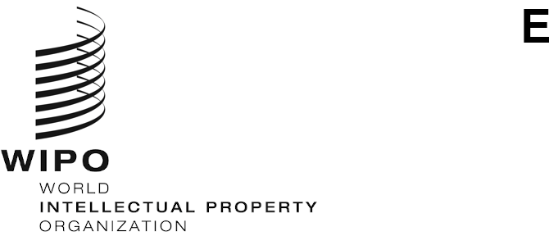
WIPO/IP/AI/2/GE/20/INF/1/PROV.2
ORIGINAL: English
DATE: JUNE 19, 2020

WIPO Conversation on Intellectual Property (IP) and Artificial Intelligence (AI)

Second Session
Virtual meeting, July 7 to 9, 2020

Provisional Agenda
prepared by the WIPO Secretariat

Tuesday, July 7, 2020
13.00 – 13.15 Opening
Mr. Francis Gurry, Director General, World Intellectual Property Organization (WIPO)
13.15 – 13.30 Introductory remarks
H.E. Mr. François Rivasseau, Ambassador, Permanent Representative of France to the United Nations and other International Organizations in Geneva

Session 1: IP protection for AI-generated and AI-assisted works and inventions and related topics
Issue 2: Patents: Inventorship and Ownership
Issue 6: General Policy Considerations for the Patent System
Issue 7: Copyright and Related Rights: Authorship and Ownership
Issue 9: Deep Fakes
Issue 10: Copyright: General Policy Issues
Issue 12: Designs: Authorship and Ownership
13.30 – 13.45 Introduction to Session 1
H.E. Mr. Omar Sultan Al Olama, Minister of State for Artificial Intelligence, United Arab Emirates
Mr. Ahmed Elgammal, Professor, Department of Computer Science, Rutgers University, United States of America
13.45 – 14.50 Interventions
Chair: H.E. Mr. François Rivasseau
14.50 – 15.00 Closing day 1
H.E. Mr. François Rivasseau

Wednesday, July 8, 2020
13.00 – 13.10 Opening day 2
H.E. Mr. François Rivasseau

Session 2: AI inventions: Patentability, disclosure and guidelines
Issue 3: Patentable Subject Matter and Patentability Guidelines
Issue 4: Inventive Step or Non-Obviousness
Issue 5: Disclosure
13.10 – 13.25 Introduction to Session 2
Judge Klaus Grabinski, Federal Court of Justice, Germany
Mr. Santosh Mohanty, Vice President, Tata Consultancy Services, India

13.25 – 14.50 Interventions
Chair: H.E. Mr. François Rivasseau
14.50 – 15.00 Closing day 2
H.E. Mr. François Rivasseau

Thursday, July 9, 2020
13.00 – 13.10 Opening day 3
H.E. Mr. François Rivasseau

Session 3: Data: Copyright in Training Data, Further Rights in Data and Trade Secrets
Issue 8: Copyright Infringement and Exceptions
Issue 11: Further Rights in Relation to Data
Issue 14: Trade Secrets
13.10 – 13.20 Introduction to Session 3
Judge Kathleen O’Malley, United States Court of Appeals for the Federal Circuit, United States of America
13.20 – 14.50 Interventions
Chair: H.E. Mr. François Rivasseau
14.45 – 15.00 Closing
H.E. Mr. François Rivasseau
Mr. Francis Gurry

[End of document]

