 | 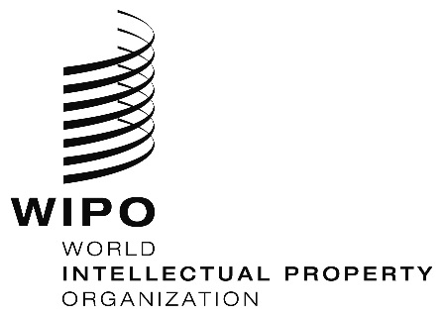 | E
WIPO/ACE/9/5
ORIGINAL: English
DATE: December 20, 2013

Advisory Committee on Enforcement

Ninth Session
Geneva, March 3 to 5, 2014

Cambodia’s Preliminary Alternative Dispute Resolution

prepared by Op Rady, Deputy Director, Department of Intellectual Property Rights, Ministry of Commerce, Cambodia

I. Background oN IP Enforcement

In compliance with the requirements under the World Trade Organization Agreement on Trade-Related Aspects of Intellectual Property Rights (TRIPS Agreement), Cambodian intellectual property (IP) laws contain provisions for effective enforcement of intellectual property rights (IPRs). In addition, the Civil Code and the Civil Procedure Code also provide procedures for civil remedies and provisional measures. On border measures, in addition to the IP laws that allow competent authorities including Camcontrol, Economic Police, Customs and the Prosecutor’s Office to the Court of First Instance to suspend the release of goods suspected of being counterfeit; some provisions in the Law on Customs and Excises explicitly require and empower the customs authorities to address all types of IPR infringement. The draft Sub-Decree implementing this Law will be prepared by the General Department of Customs and Excises of Cambodia and will reflect this crucial responsibility of Customs to combat IP infringement at the borders. For violations in relation to pharmaceutical products, Cambodia also applies the Law on the Management of Pharmaceutical Products, which, in some cases, can be used in conjunction with the Law concerning Marks, Trade Names and Acts of Unfair Competition, particularly for imported counterfeits.

The IP enforcement system in Cambodia is guided by a coordination mechanism of separate authorities responsible for IPRs enforcement. Each authority has its own structure and policy to deal with IP infringement. However, in order to further strengthen IP enforcement, those authorities have been encouraged to join hands under the supervision of the National Committee for Intellectual Property Rights established in 2008 to assure a unique national policy on IP, to enable smooth cooperation between ministries and institutions concerned, and crucially, to prepare, disseminate, and enforce IP laws and regulations. To fulfill these duties, two Sub-Committees, namely, a Sub-Committee for IP Enforcement and a Sub-Committee for Education and Public Awareness will be established in 2014. The purpose of setting up the two Sub-Committees is to clarify the responsibilities of each competent authority, including Economic Police, Camcontrol, Customs, the Inter-Ministerial Committee for Suppression of Movie and Video Infringement, and the Prosecutor’s Office to the Court of First Instance in Cambodia. Moreover, a Sub-Decree on IP enforcement procedures will be drafted in the near future. Coordination among enforcement bodies will be strengthened with a clear demarcation of the area of responsibility of each enforcement authority. In addition, communication between right-holders and the authorities will be formalized with clear deadlines for official replies and with the obligation to justify administrative decisions.

In Cambodia there are three levels of court: Provincial/Municipal Court, Appeals Court, and the Supreme Court. The decision of the Supreme Court is final. Future plans focus on better specialization within the courts, namely, criminal, administrative, civil and commercial courts. The Royal Government of Cambodia is expected to establish a commercial court, which can be a specialized organ, and an efficient tool to deal with commercial and IP disputes. The plaintiff may bring action directly to the court or enforcement agencies, or alternatively, both parties are able to go to the Arbitration Center.

Currently, there are no special courts for IP or specialized judges in Cambodia. IPR cases are not prevalent. Cambodia needs to prepare itself to have capable and experienced courts to cope with increased cases occurring due to economic development. The structure of the hearing process will be similar to the court rules and procedures in other countries. The presiding judge will have legal background and will be accompanied by two non-legal associate judges with expert knowledge in the field.

There are four vitally important pillars to make the IP system more effective (1. efficient laws and regulations in place; 2. strong IP enforcement bodies; 3. public awareness; 4. sufficient budgetary resources). The lack of collaboration among IP enforcement agencies and enforcement procedures also causes delays and inefficiencies to crackdown on IPR infringements. Although the Inter-Ministerial Committee on Suppression of Movie and Video Infringement was established in Cambodia, for the actual implementation of laws, guidelines and collaboration are needed. The establishment of the Sub-Committee for IP Enforcement aims to put in place the policy for IP enforcement agencies to efficiently perform their duties. Moreover, the Sub-Decree on IP enforcement procedures will fill the gaps to make IP enforcement stronger.

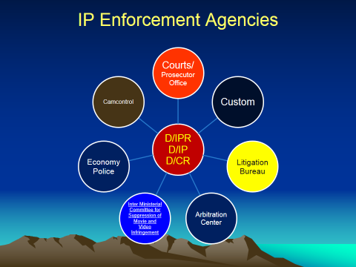

II. Preliminary Alternative Dispute Resolution (PADR)

Background

Since Cambodia is a least developed country (LDC) where the IP knowledge of the public is still limited and where judges, prosecutors and enforcement officials lack IP knowledge and experience in dealing with IP matters, the court may request for IP examiners’ recommendation or participation in the hearing, before rendering a decision in IP cases. Bringing IP cases to court is normally time consuming and costly. Some IP cases need four to five years to complete the proceedings. Alternatively, local practitioners and right holders have requested the Ministry of Commerce to play a role as intermediary providing PADR before parties initiate court proceedings.

Pursuant to Article 1(1) of TRIPS Agreement, which provides “Members shall be free to determine the appropriate method of implementing the provisions of this Agreement within their own legal system and practice”, Member States are encouraged to adopt appropriate methods to enforce IPR effectively. In terms of Cambodia being an LDC, PADR outside the court system is being encouraged as a flexible procedure among others for resolving IP disputes. Therefore on September 18, 2007, the Minister of Commerce issued a Declaration establishing the Bureau of Litigation responsible for IP litigation under the Department of Intellectual Property Rights (IP office), Ministry of Commerce.

Role and Procedure

The plaintiff may take action against the infringer before the Bureau of Litigation acting as intermediary. The PADR procedure serves as a good alternative to long trials, taking from 2 weeks to several weeks to reach agreement and as such is cost-effective, necessitating only a nominal administrative fee. The interested parties may also settle their dispute before the Ministry of Commerce or the rights owner can directly file a lawsuit against the infringer to the court. In light of the challenges faced by the judiciary, legal practitioners normally advise their clients to reach a settlement before the Ministry of Commerce, as court procedures could be lengthy, costly and possibly inconsistent. If reconciliation fails, the rights owner is still free to file a lawsuit.

The structure of the PADR procedure is organized through a negotiation hearing, being similar to a court hearing process or a mediation. The presiding intermediary will comprise of the director or deputy director of the IP office, alternatively accompanied by the chief or the deputy chief of the Bureau of Litigation and a secretary with IP knowledge and experience.

The procedure may be non-binding or binding. Sometimes with administrative imposition, a presiding neutral assists the parties in reaching a settlement of their dispute, based on the parties’ respective interests. Settlement results are normally enforceable as a contract.

The procedure, at the request of any interested party to a dispute, engages the assistance of a neutral intermediary from the IP office to facilitate negotiations between the parties with differing legal points of view to resolve their differences amicably.

Reconciliation is akin to a “without prejudice” negotiation session under the auspices of the intermediary from the IP office (Royal civil servants) who are more respected than an arbitrator or mediator, in Cambodia.

The presiding intermediary will guide and regulate the process, to prevent the parties from digging into their respective positions. The outcome of the resolution is determined by the parties. Mostly, a consensual (contractually agreed) private and confidential dispute resolution mechanism is the chosen (flexible) resolution by the parties; it is also seen as more appropriate for the reputation of their business. Interest-based negotiation is assisted by the presiding intermediary whom the parties may select. Parties may commence PADR resolution but they can also go to court at any time. As party autonomy governs the process, the presiding intermediary has no decision authority. The parties may nevertheless ask the presiding intermediary to give an opinion and sometimes the presiding intermediary may impose on the parties to reach a resolution through an administrative procedure. Moreover, the presiding intermediary has no power to enforce a ruling. Therefore, damages, compensation, seizure of goods and destruction of goods can only be granted upon the agreement of both parties. However, in case of counterfeit goods which affect public health, the presiding intermediary encourages parties, with an explanation of prosecution and IPR penalty provisions under court procedure, to destroy those goods in order to avoid returning such goods into the channel of commerce.

The PADR is Appropriate to IPR Disputes for the following characteristics:

- Single neutral procedure
- Party autonomy
- Neutrality
- Expertise
- Efficiency
- Confidentiality
- Finality of agreement
- Preserving party relationships

A Single Neutral Procedure IPRs are often used as a business tool in international collaborations and protected through multiple procedures in different jurisdictions with a risk of inconsistent outcomes. As such, IP disputes often involve parties from different parts of the country, and multi-jurisdictional commerce. As courts have limited experience with IPR, with risk of inconsistent results, at the request of any party to the dispute, the matter may be resolved under PADR (avoiding the expense (time and cost) and complexity of multi-jurisdictional litigation).

Party Autonomy PADR is mostly of a private nature. The intermediary offers parties the opportunity to exercise greater control over the way the dispute is resolved (bargaining power in negotiation process). Negotiation for compensation between parties is better than the prosecution of an infringer, with the possibility of a jail sentence under the court procedure. In some cases, however, the intermediary may also impose on the parties to reach an agreement through an administrative procedure. Since the IP office administers the registrations, the IP office may otherwise order the cancellation of the registrations if the registered mark owner has used that mark differently from the original form which has been registered and infringed the rights of another person’s registered mark. The IP office relies on the relevant provisions (Article 24(3) and (4)) in the Sub-Decree on the Implementation of the Law concerning Mark, Trade Names and Acts of Unfair Competition, to encourage the infringer to reach an agreement as otherwise the registered mark will be removed from the register.

Neutrality To avoid any local court advantage that one of the parties may enjoy in the context of court litigation, where familiarity with the applicable law and local processes can offer significant strategic advantages to one party, the PADR provides a chance to both parties exercise negotiation power to find a resolution (better than in the court system), or alternatively, to refuse to reach an agreement. In the court system, however, the judge makes a judgment, which may not always satisfy the parties

Expertise In PADR, the presiding intermediary has special expertise in IPR required for the resolution of the disputes.

Confidentiality In PADR, the parties can keep the proceedings and any result confidential if they wish so. This allows the focus to be kept on the merits of the dispute, and may be of special importance, whereas often in the case of IPR disputes, commercial reputation is at stake. Both parties can enforce the consensual agreement as a contract. PADR is a private procedure except when agreed otherwise; all parties may preserve confidentiality regarding the settlement agreement.

Efficiency Recognizing the need for efficient dispute resolution procedures, PADR offers parties control (short deadlines) to reach a quick result as they wish; when the infringing party tries to delay the right holder’s proceedings, the intermediary may preserve the right to set a fixed deadline for the closure of the proceedings. Through a comprehensive dispute resolution, a procedure, and with the assistance of a neutral expert, a final settlement agreement can be achieved.

Finality of Agreement Whereas court decisions can be generally contested through one or more rounds of litigation, PADR agreements are not normally subject to appeal; in case of breach, parties may appeal to the court.

Preserving Party Relationships IPRs are generally exploited in long-term relationships between partners. PADR is a private and administrative procedure, which takes place at the request of the parties, and which is flexible, tailoring to the parties’ needs. Furthermore, confidentiality of the procedure helps parties to focus on the merits of the dispute, without concern about its public implications.

Disposal of Infringing Goods

Once a reconciliation session takes place between the right holder and the infringer, the right holder obtains the full right to make a determination on how the counterfeit goods are to be disposed. Counterfeit goods which do not affect public health (e.g., t-shirts, shoes, toys, etc.), the Ministry of Commerce encourages both parties to reach an agreement to dispose such goods into channel of commerce for a certain period of time by providing the certificate of production issued by the concerned ministries. Counterfeit goods which affect public health (e.g., medicine, chili sauce, car spare parts, etc.) are destroyed. The final decision on the disposal of the counterfeit goods shall be made by the right holder; however, the infringer may persuade the right holder to provide him a chance to clean up his infringement activities.

Collaboration with other Enforcement Agencies

In addition to its responsibility for PADR, the IP office also provides recommendations on IP cases to the court or participates in hearings under the court procedure. Moreover, at the request of enforcement agencies, the IP office provides a validity check of the registration status to those agencies before they take action against infringement.

Partnership with Private Sector against Infringement

In order to reduce the amount of counterfeit goods lawsuits, the IP office has also collaborated with other enforcement agencies, through a Memorandum of Understanding, to persuade the private sector, such as landlords, super markets or store owners, not to sell counterfeit goods.

Conclusion

Throughout the Cambodian practices, we have established that the people of a least developed country have limited IP knowledge and experience to deal with IP matters. Therefore the IP office should not only play a role in granting and administering IP rights but the IP office ought to take part in IP enforcement, PADR, and collaboration with enforcement agencies, to take place prior to the court procedure.

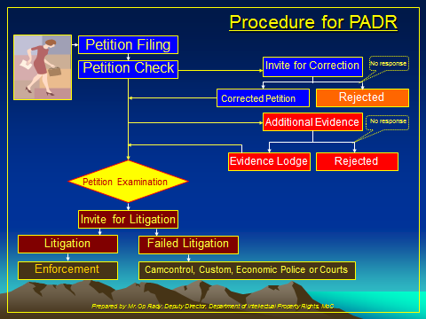

Note:

- Invitation for litigation can be made to the parties at least seven days before starting a litigation hearing.
- Generally, such invitation can be made not more than three times, except in complicated cases, where the invitation can be made two times more.

Best Practical Cases

Statistics of IP Infringement, 2011
Year | Petition Received | Preliminary Alternative  Dispute Resolution |  | Carried over
 |  | Withdrawal and Rejection | Amendment, Warning Letter, Certification of Validity,  Dispute Resolution
2010 |  |  |  | 3
2011 | 26 | 1 | 19
Total | 29 | 1 | 19 | 9

Statistics of IP Infringement, 2012
Year | Petition Received | Preliminary Alternative  Dispute Resolution |  | Carried over
 |  | Withdrawal and Rejection | Amendment, Warning Letter, Certification of Validity,  Dispute Resolution
2011 |  |  |  | 9
2012 | 29 | 4 | 20
Total | 38 | 4 | 20 | 14

Statistics of IP Infringement, 2013
Year | Petition Received | Preliminary Alternative  Dispute Resolution |  | Carried over
 |  | Withdrawal and Rejection | Amendment, Warning Letter, Certification of Validity,  Dispute Resolution
2012 |  |  |  | 14
2013 | 19 | 5 | 19
Total | 33 | 5 | 19 | 9

[End of document]

The views expressed in this document are those of the author alone, and not those of the Secretariat or any of the Member States of WIPO

