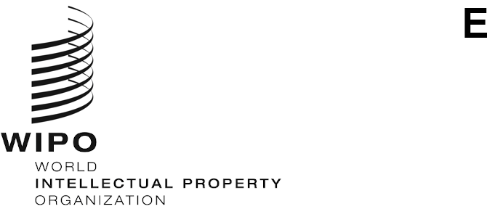
CDIP/31/INF/5
ORIGINAL: ENGLISH
DATE: October 11, 2023

Committee on Development and Intellectual Property (CDIP)

Thirty-First Session
Geneva, November 27 to December 1, 2023

COMPILATION OF TOPICS PROPOSED BY THE SECRETARIAT FOR FUTURE WEBINARS ON TECHNICAL ASSISTANCE
prepared by the Secretariat
The Committee on Development and Intellectual Property (CDIP), at its thirtieth session held in April 2023, approved the Revised Document on Future Webinars (CDIP/30/8 REV.), which contains the delivery strategy for the webinars on technical assistance.
As described in document CDIP/30/8 REV., “every year, during the second half, the Secretariat would share with Member States, through Group Coordinators, a list of proposed topics for webinars for the following year, indicating the objective(s) and target audience(s)”. The document also states that “a roster of topics would be published on the web page dedicated to webinars on technical assistance, indicating the webinars already held, the ones scheduled to be held, as well as other proposals that would be kept in the pipeline as received”.
Accordingly, the Secretariat shared two topic proposals for Future Webinars with Group Coordinators to be added to the roster of topics. The Annex to this document includes those proposals.
The Committee is invited to take note of the information contained in the Annex to the present document.
[Annex follows]
FUTURE WEBINARS ON TECHNICAL ASSISTANCE
Topics proposed by the Secretariat

- Impact-oriented Technical Assistance and Capacity Building: Factors for Success and Lessons Learned

Objective: In line with the WIPO’s current Medium-Term Strategic Plan (MTSP) 2022 – 2026, the Organization has placed an even greater focus on development and creation of tangible benefits through its technical assistance and capacity building initiatives. The webinar will serve as a platform for a diverse panel of experts to share experiences and provide insights into effective strategies, tools and lessons learned for maximizing the developmental impact of technical assistance interventions on the ground through practical use of IP.

Target Audience: The webinar is intended for WIPO Member States and interested stakeholders.

- Virtual Technical Assistance and Capacity Building: A Critical Look at the Advantages and Limitations

Objective: The restrictions on mobility stemming from the COVID-19 pandemic, combined with rapid advancement of technology, have resulted in redesigning of WIPO’s technical assistance and capacity building initiatives. Remote solutions and virtual assistance became practical and cost-effective choice to connect with a broader audience. While the implementation of WIPO activities start to return to their normal rhythm of engagement, the lessons learned during the pandemic have highlighted the value of virtual approaches, making them a lasting component of technical assistance. The purpose of the Webinar is to provide an opportunity for a diverse panel of experts to explore the advantages and limitations of virtual technical assistance and identify best practices that could be incorporated into the future work of the Organization.

Target Audience: The webinar is intended for WIPO Member States and interested stakeholders.

[End of Annex and of document]

