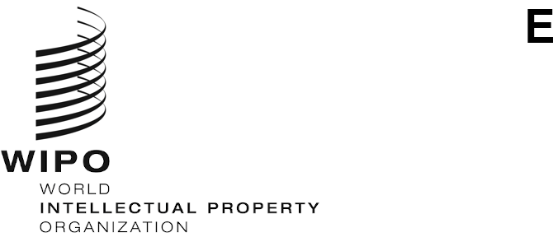
CDIP/31/11 REV.
ORIGINAL: ENGLISH
DATE: october 9, 2023

Committee on Development and Intellectual Property (CDIP)

Thirty-First Session
Geneva, November 27 to December 1, 2023
COMPILATION OF TOPICS PROPOSED BY MEMBER STATES TO BE ADDRESSED UNDER THE AGENDA ITEM ON “INTELLECTUAL PROPERTY AND DEVELOPMENT”

prepared by the Secretariat
- The WIPO General Assembly (GA) at its forty-ninth session, held in October 2017, took a decision which, inter alia, requested to “add new agenda item to the CDIP agenda, named IP and development to discuss IP and development-related issues as agreed by the Committee, as well as those decided by the GA”.
- The CDIP, at its thirtieth session held in April 2023, while discussing the Future Work, decided that “proposals for topics to be discussed under Agenda Item on “IP and Development” beyond the thirty-first session of the Committee should be sent to the Secretariat”.

- The Annex to this document contains a compilation of all proposals submitted by Member States in the order of the receipt by the Secretariat.

- The Committee is invited to consider the Annex hereto.

[Annex follows]
PROPOSAL BY THE DELEGATION OF BRAZIL
- AI challenges for IP and development
PROPOSALS BY THE GROUP B
- Proposal 1: IP and the Judiciary: Building capacities and expertise
Comment by the Group B:
From past topics proposed by Members, there seems to be interest in this topic. Accordingly, it may be taken up in future sessions.

Intellectual property law, being a highly specialised and dynamic field, requires that countries consistently engage in building judicial capacity in this area. It might thus be useful to share experiences relating to how Member States improve and update the capacity of judges and related judicial staff in the field of IP. It would be interesting to understand what issues fall within the purview of specialised IP courts in members’ jurisdictions and instances in which non-specialised courts have to deal with IP. In situations where the latter is the case, Members may benefit from an information exchange on how adequate IP expertise on the part of judicial officers and access to necessary information is ensured.

- Proposal 2: Mainstreaming IP in development cooperation programs
Comment by the Group B:
New proposal. IP can play a crucial role in development and contribute to SDGs. A robust IP framework helps boost private sector confidence and signals a stable business environment to foreign and domestic investors. IP policy can also be a means to improve the competitiveness of products coming from rural areas. There are thus benefits to including IP in north-south, south-south, and triangular development cooperation. Accordingly, a discussion sharing experiences and challenges of MS in mainstreaming IP in development through capacity-building activities and/or technical cooperation projects would provide useful insights. This may include multilateral, regional and national capacity-building activities. It would be especially useful to understand lessons learnt, best practices, and insights from developing and least developed countries that have partnered in development cooperation programs.
PROPOSAL BY THE DELEGATION OF POLAND
- Creativity - society - development: how to solve aging societies’ dilemma by delivering opportunities for youth – IP in use in fixing challenges of today’s world
Comment by the Delegation of Poland:
Seeking new IP-related solutions to deliver quality-to-value services to aging societies.
PROPOSALS BY THE DELEGATION OF SLOVENIA
- Proposal 1: Intellectual property and innovation in the event of natural disasters

- Proposal 2: Intellectual property and education

- Proposal 3: Intellectual property in the digital world
PROPOSALS BY THE AFRICAN GROUP
- Proposal 1: Building the capacity of universities to manage and commercialise IP: Transferring IP and technology
- Proposal 2: Digital transformation for IP offices: strengthening capacity-building programmes and services

- Proposal 3: Bolstering IP infrastructures to address the developmental needs of countries
- Proposal 4: Leveraging IP for achieving the SDGs: Strengthening Global Partnerships, South-South and triangular cooperation.
[End of Annex and of document]

