 |  | E
H/LD/WG/9/5
ORIGINAL: English
DATE: NOVEMBER 6, 2020
Working Group on the Legal Development of the Hague System for the International Registration of Industrial Designs
Ninth Session
Geneva, December 14 to 16, 2020

CRITERIA FOR THE SELECTION OF ADDITiONAL LANGUAGES FOR INTRODUCTION Into the hague System
Document prepared by the International Bureau

I. INTRODUCTION
1. At its eighth session, held from October 30 to November 1, 2019, the Working Group on the Legal Development of the Hague System for the International Registration of Industrial Designs (hereinafter referred to as the “Working Group” and the “Hague System”) discussed document H/LD/WG/8/5, which is entitled “Possible Options for the Introduction of New Languages into the Hague System”.
2. During that session, the Delegation of the Republic of Korea proposed to include Korean as a filing language into the Hague System. The delegation emphasized that the introduction of new languages as filing languages would be a reasonable way forward in view of the current financial situation of the Hague System and the inclusion of Korean would benefit the Hague System, as it would increase the number of applications from that region, in light of the statistics since the Republic of Korea has joined the Hague System in 2014. Accordingly, the Working Group requested the International Bureau to prepare, for discussion at the next session, a paper on criteria for the selection of additional languages for introduction into the Hague System.
3. Following the proposal by the Delegation of the Republic of Korea and the instruction given by the Working Group, this document presents possible criteria for the introduction of new languages into the Hague System as “filing languages”, the implementing details of this possible introduction being of course subject to further discussion by the Working Group.
4. In this regard, document H/LD/WG/9/4 describes the filing language option referred to as option “A” in that document which was slightly modified from the filing language option presented in document H/LD/WG/8/5 considered at the eighth session. For detailed features of the language implementation options, refer to document H/LD/WG/9/4, paragraphs 4 to 19.

II. possible criteria for Introducing New Languages
5. In the past, similar papers on possible criteria for introducing new languages into the Madrid and PCT Systems were discussed by their respective unions’ assemblies. Moreover, document H/LD/WG/8/5 already outlined some possible criteria for the introduction of new languages into the Hague System. Thus, the present document provides some other criteria as well as an update on those criteria already presented in the aforementioned document.

filing activitY under the Hague system
6. As a first criterion, the number of international applications and the number of designs contained therein filed under the Hague System may be taken into account.

Number of International Applications and Designs Contained Therein Under the Hague System
7. The Working Group could take into account the number of international applications filed by applicants from a Contracting Party or Contracting Parties, as well as the number of designs contained in such international applications, where a given language, other than English, French or Spanish, may be used to file domestic applications. These numbers could indicate the potential filings of international applications in that language under the Hague System.
8. Considering the top 10 origins of international applications for 2019 and focusing particularly on those where a domestic application may be filed in a language other than English, French or Spanish, it is noted that
– Korean applicants filed 1,176 applications (containing 2,736 designs),
– German applicants filed 772 applications (containing 4,487 designs),
– Swiss applicants filed 601 applications (containing 2,178 designs) which may mean when breaking up the multilingual regime of Switzerland into equivalent language shares according to domestic filing statistics, that 427 applications (containing 1,546 designs) could be attributed to German speakers and 30 applications (containing 109 designs) could be attributed to Italian speakers,
– Italian applicants filed 412 applications (containing 1,994 designs),
– Japanese applicants filed 397 applications (containing 1,152 designs),
– Chinese applicants filed 239 applications (containing 663 designs), and
– Dutch applicants filed 181 applications (containing 1,376 designs).

International Applications from the Top 20 Origins in 2019
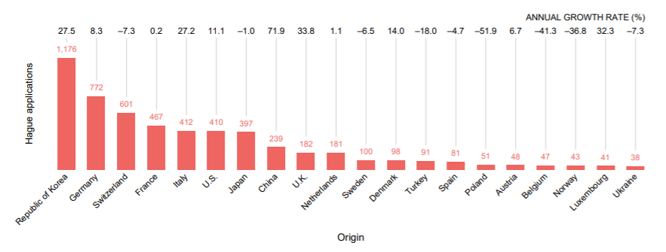

Designs Contained in International Applications from the Top 20 Origins in 2019
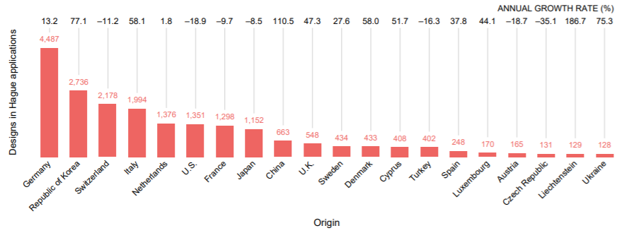
9. If the languages of the top five origins of international applications were to be taken into account, Korean, German and Italian could qualify for inclusion into the Hague System. If the languages of the top five origins of designs contained in international applications were to be taken into account, German, Korean, Italian and Dutch could qualify for inclusion into the Hague System. If the languages of the top 10 origins of international applications, or designs contained in those applications, were considered, German, Korean, Italian, Dutch, Japanese and Chinese could qualify for inclusion into the Hague System.

Threshold
10. For considering filing activities under the Hague System, the Working Group may consider, as an additional criterion, the inclusion of an eligibility threshold, for example a share of at least five, 10 or 20 per cent of the total number of designs contained in international applications or total number of applications filed in a given year for a certain amount of time, such as at least three consecutive years.
11. Based on the statistics for 2019, 21,807 designs were contained in 5,886 international applications. If the threshold was set at 20 per cent (4,361 designs), only German would meet that threshold. If the threshold was set at 10 per cent (2,181 designs), only German and Korean would meet that threshold. If the threshold was set at five per cent (1,090 designs), German, Korean, Italian, Dutch and Japanese would meet that threshold.
12. Similarly, based on the statistics for 2019, 5,886 international applications were filed in that year. If the threshold was set at 20 per cent (1,177 applications), no language would meet that threshold (noting that Korean was short of that threshold by one application). If the threshold was set at 10 per cent (589 applications), only Korean and German would meet that threshold. If the threshold was set at five per cent (294 applications), Korean, German, Italian, Dutch and Japanese would meet that threshold.
13. The Working Group may also consider a dual eligibility threshold of both combinations, and propose that the threshold is met for a certain number of years, for example for three consecutive years, before a new language of filing was included into the Hague System.

filing activities abroad
14. As a second criterion, the volume of applications filed abroad may be taken into account. This criterion could provide an indication of the potential use of the Hague System and,
in extenso, of the relevance of specific languages for filing purposes.

Number of Designs Contained in Applications Filed Abroad
15. Applicants seeking design protection in foreign jurisdictions can either file applications directly with a national or regional Office or, where possible, through the Hague System. Thus, the Working Group could also consider the number of designs contained in applications filed abroad directly or through the Hague System by residents in countries where a given language, other than English, French or Spanish, may be used to file domestic applications.
16. In this regard, the top 10 origins for applicants seeking protection abroad for their designs are provided in the table below. In 2018, 278,766 designs were contained in applications filed abroad (direct filing and through the Hague System) by those applicants. In that year, by order of the number of designs for the top 10 origins, applications filed abroad originating from Germany contained 39,960 designs, from the United States of America 38,735 designs, from China 22,542 designs, from Italy 20,650 designs, from Switzerland 19,088 designs, from France 18,892 designs, from Japan 18,191 designs, from the United Kingdom 11,423 designs, from the Republic of Korea 8,504 designs and from the Netherlands 7,217 designs.

Designs Contained in Applications Filed Abroad from the Top 10 Origins in 2018

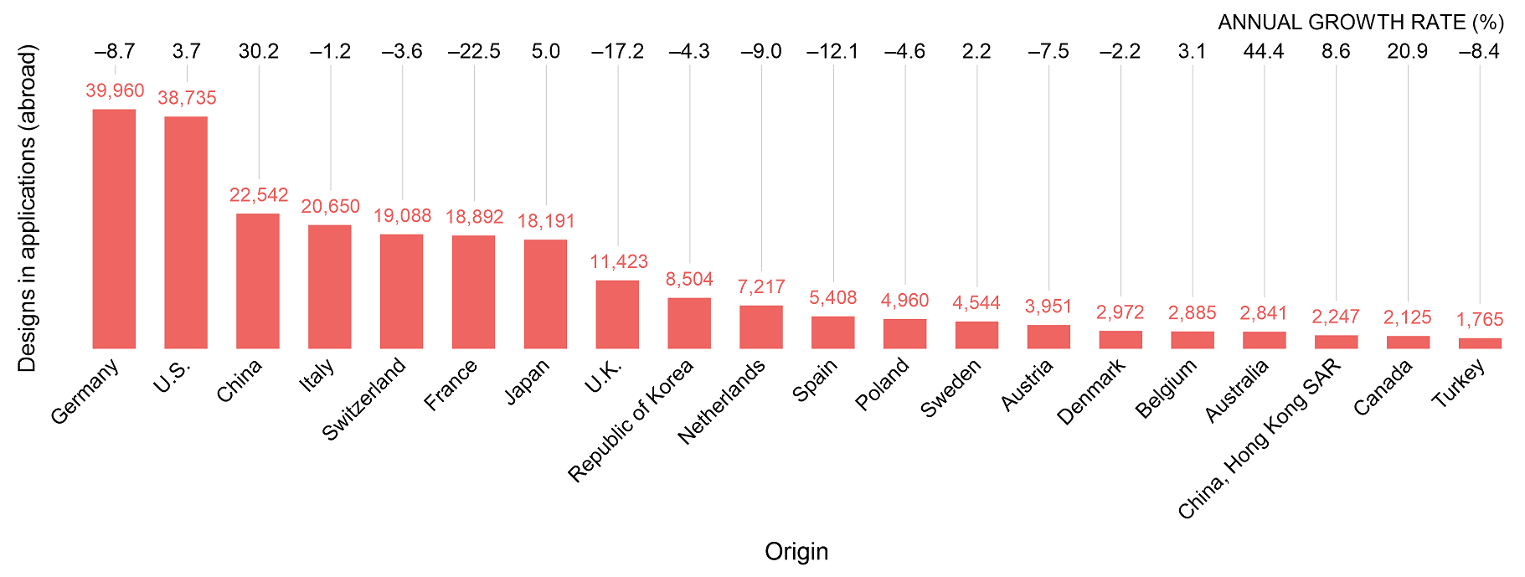
17. If the top five origins for applicants seeking protection abroad were taken into account, German, Chinese and Italian could be considered for inclusion into the Hague System, in addition to the current three languages of the Hague System. If the top 10 origins for applicants seeking protection abroad were taken into account, German, Chinese, Italian, Japanese, Korean and Dutch could be considered for inclusion into the Hague System.

Threshold
18. For considering filing activities abroad, the Working Group may, again, consider the inclusion of an eligibility threshold, for example a total number of designs contained in applications filed abroad in a given year for a certain amount of time, such as for three consecutive years. If the threshold was set at 30,000 designs contained in applications filed abroad, only German would meet that threshold. If the threshold was set at 20,000 designs, German, Chinese and Italian would meet that threshold. If the threshold was set at
10,000 designs, German, Chinese, Italian and Japanese would meet that threshold.

Official languages of the United nations
19. The Working Group may take into account the official languages of the United Nations.
20. The six official languages of the United Nations are Arabic, Chinese, English, French, Russian and Spanish.
21. Language coverage for documentation for meetings of the WIPO Main Bodies, Committees and Working Groups, as well as for core and new publications, extends to the six official languages of the United Nations, in accordance with the language policy adopted by the General Assembly of WIPO in September 2010. Nevertheless, that policy does not currently apply to services provided under WIPO-administered treaties, such as international registration services provided under the Madrid and Hague Systems.

speakers of a language (total and native)
22. The Working Group may take into account the total number of speakers of a language in the world. This may give an indication as to how many applicants could potentially file applications in their language if a given language was included into the Hague System.
23. According to internet resources (refer to the table entitled “Distribution of Languages in the World” provided in Annex I to this document), in terms of the total number of “speakers”, English, Chinese, Hindi, Spanish, French, Arabic, Bengali, Russian, Portuguese and Indonesian ranked as the top 10 languages in the world in early 2020. If the top 10 spoken languages were taken into account, Chinese, Hindi, Arabic, Bengali, Russian, Portuguese and Indonesian could be considered for inclusion into the Hague System, in addition to the current three languages of the Hague System.
24. In terms of the total number of “native speakers”, Chinese, Spanish, English, Hindi, Bengali, Portuguese, Russian, Japanese, Western Punjabi and Marathi ranked as the
top 10 languages in the world in early 2020. If the top 10 languages were taken into account, Chinese, Hindi, Bengali, Portuguese, Russian, Japanese, Western Punjabi and Marathi could be considered for inclusion, in addition to the current three languages of the Hague System.

Official languages of States
25. The Working Group may take into account official languages of States. An official language is a language used for official purposes, especially as a medium of a national government.
26. If the Working Group considered official languages according to the number of States, amongst the top 25 languages spoken in the world (other than English, French or Spanish), Arabic, Portuguese, German, Swahili, Italian, Russian, Tamil, Chinese, Hindi, Bengali, Urdu, Japanese, Turkish and Korean are official languages in more than one State (refer to the table entitled “Distribution of Languages in the World” provided in Annex I to this document).

Official languages of member states
27. The Working Group may also take into account the official languages of States on a member State basis, noting that this parameter would change with each new accession.
28. In this regard, amongst the top 25 languages spoken in the world (other than English, French or Spanish), Arabic, German, Italian, Korean, Turkish and Russian are official languages in more than one member State, according to the current membership (refer to the table entitled “Distribution of Languages in the World” provided in Annex I to this document).

further factors
29. Further factors that might be of relevance for consideration by the Working Group are presented in Annex II to this document. Those are the languages used amongst different WIPO services (Section I), the use of the resources of the WIPO website in different languages (Section II), and the changes in filing activities after the addition of languages in the Hague and PCT Systems (Section III).

iii. summary of findings
30. The languages to be considered for a possible introduction as fling languages under the Hague System vary largely from one criterion to another, with some languages appearing more frequently than others. Notably, and using, where applicable, the most lenient of the suggested thresholds, it appears that:
– if the Working Group were to take into account filings under the Hague System, both for the number of international applications as well as the number of designs contained therein, German, Korean, Italian, Dutch and Japanese could be considered;
– if the Working Group were to take into account non-resident filings, by design count, German, Chinese, Italian and Japanese could be considered;
– if the Working Group were to take into account the official languages of the United Nations, Chinese, Arabic and Russian could be considered;
– if the Working Group were to take into account the total number of “speakers” of a given language in the world, a large list of languages, starting with Chinese, Hindi, Arabic, Bengali, Russian and Portuguese, could be considered;
– if the Working Group were to take into account the total number of “native speakers” of a given language in the world, a large list of languages, starting with Chinese, Hindi, Bengali, Portuguese, Russian and Japanese, could be considered;
– if the Working Group were to take into account the number of States for which a given language is an official language, amongst the top 25 most-spoken languages of the world, a large list of languages, starting with Arabic, Portuguese, German, Swahili, Italian and Russian, could be considered; or
– if the Working Group were to take into account the number of member States for which a given language is an official language, then, amongst the
top 25 most-spoken languages of the world and according to the current Hague membership, Arabic, German, Italian, Korean, Turkish and Russian could be considered, these being official languages in more than one member State.
31. The Working Group is invited to:
    - discuss and comment on the contents presented in this document; and,
(ii) provide guidance to the International Bureau on a possible way forward.

[Annexes follow]

Distribution of Languages in the World

Language | Rank (total) | Total (millions) | Native Speakers (millions) | States with that official language | Member States with that official language
English | 1 | 1132 | 379 | 60 | 10
(Mandarin) Chinese | 2 | 1117 | 918 | 2 | 1
Hindi | 3 | 615 | 341 | 2 | 0
Spanish | 4 | 534 | 460 | 20 | 2
French | 5 | 280 | 77 | 29 | 13
Standard Arabic | 6 | 274 | NA | 23 | 5
Bengali | 7 | 265 | 228 | 2 | 0
Russian | 8 | 258 | 154 | 4 | 2
Portuguese | 9 | 234 | 221 | 9 | 1
Indonesian | 10 | 199 | 43 | 1 | 0
Urdu | 11 | 170 | 69 | 2 | 0
Standard German | 12 | 132 | 76 | 6 | 5
Japanese | 13 | 128 | 128 | 2 | 1
Swahili | 14 | 98 | 16 | 6 | 1
Marathi | 15 | 95 | 83 | 1 | 0
Telugu | 16 | 93 | 82 | 1 | 0
Western Punjabi | 17 | 93 | 93 | 1 | 0
Wu Chinese | 18 | 82 | 81 | 1 | 0
Tamil | 19 | 81 | 75 | 3 | 1
Turkish | 20 | 80 | 69 | 2 | 2
Korean | 21 | 77 | 77 | 2 | 2
Vietnamese | 22 | 77 | 76 | 1 | 1
Yue Chinese | 23 | 74 | 73 | 1 | 0
Javanese | 24 | 68 | 68 | 1 | 0
Italian | 25 | 68 | 65 | 4 | 3
(Sources: visualcapitalist.com referencing Ethnologue Languages of the World, Encyclopedia Britannica, Wikipedia, July 2020)

[Annex II follows]

further factors

I. Language use amongst different wipo services
1. The filing activities under the Hague and PCT Systems are presented as below. The filing activities under the Madrid System are not included as the Madrid System has the same language regime as the Hague System. The languages used to provide the services of the WIPO Arbitration and Mediation Center (AMC) are also outlined.

The Hague System
2. Under the Hague System, in 2019, 89.2 per cent of Hague applications were filed in English, whereas French accounted for almost 10 per cent and Spanish for one per cent.

Distribution of Hague Applications by Language of Filing, 2009 to 2019
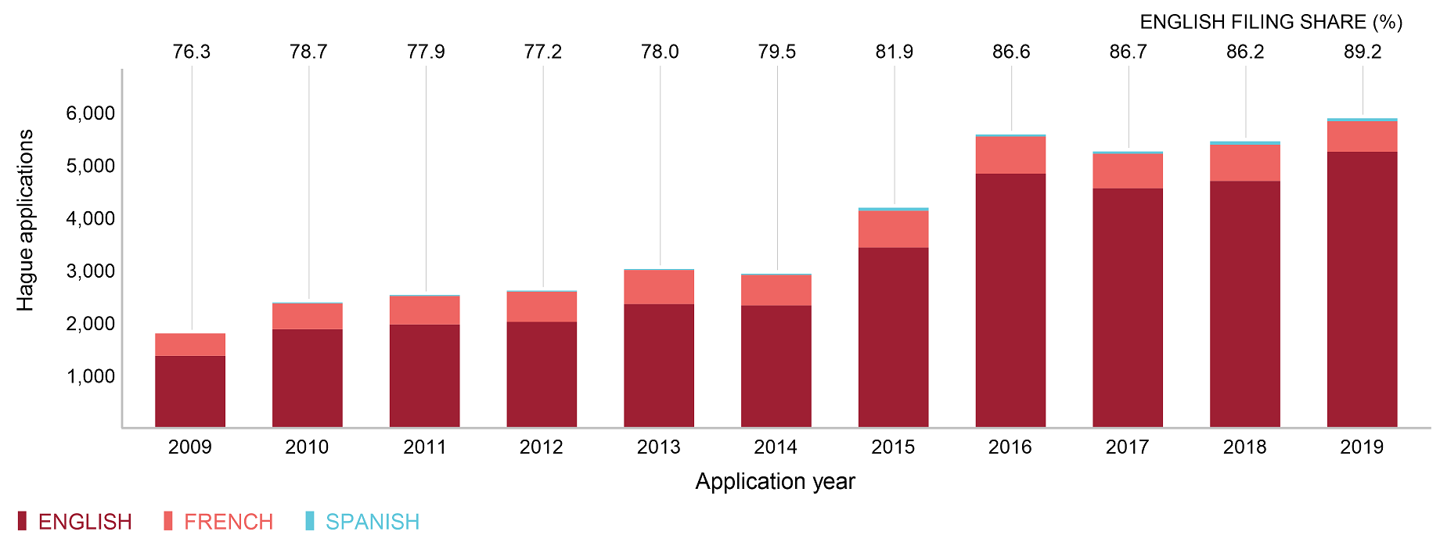

The PCT System
3. The PCT System has 10 publication languages. The vast majority of PCT applications are published in the language in which they were filed. In 2019, around 45 per cent were published in English, almost 20 per cent in Japanese, 19 per cent in Chinese, seven per cent in German, six per cent in Korean, two per cent in French, 0.6 per cent in Spanish, 0.5 per cent in Russian, 0.2 per cent in Portuguese and 0.01 per cent in Arabic.

Distribution of PCT Applications by Language of Publication, 2005 to 2019
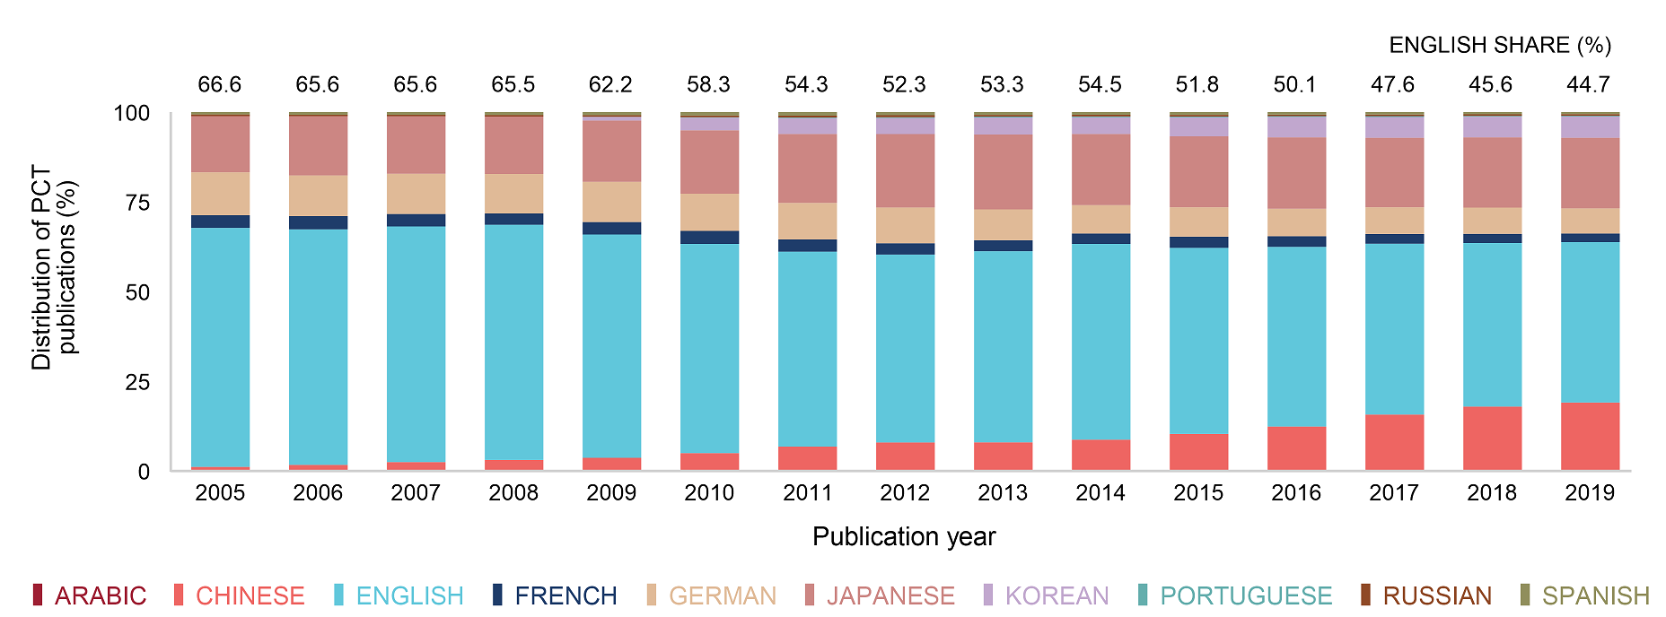

Distribution of PCT Applications by Language of Publication, 2019
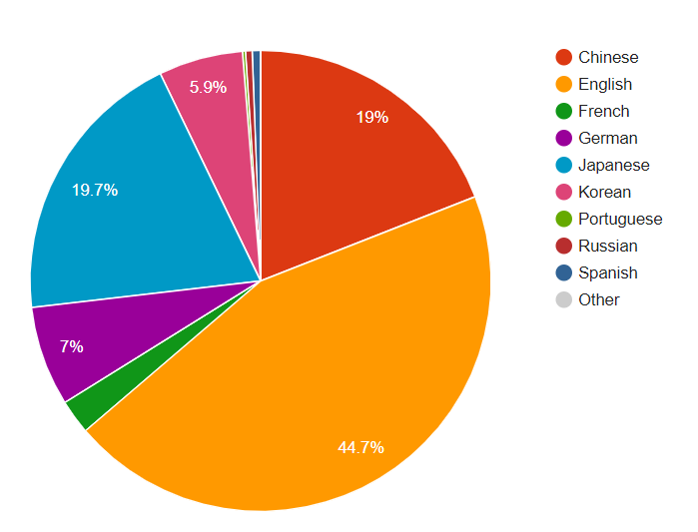

The WIPO Arbitration and Mediation Center (AMC)
4. The AMC administers mediation, arbitration and expert determination cases. The language of these proceedings is subject to the agreement between the parties or is determined by the arbitrator/mediator. In practice, these proceedings have been conducted in several languages including Chinese, English, French, German, Italian, Korean, Portuguese and Spanish.
5. The AMC also administers domain name case disputes. In general, unless otherwise agreed by the parties or specified otherwise in the Registration Agreement (the agreement between a Registrar and a domain-name holder), the language of the administrative proceeding is the language of the Registration Agreement. In practice, these proceedings have been conducted in several languages, while around 90 per cent were conducted in English.

II. Use of Resources of the WIPO Website in Different Languages
6. The International Bureau has compiled some information and data in relation to the use of WIPO free online resources in the different available languages. While the use of the online resources in the different languages does not provide a direct indication of the value of adding another language to the Hague System, it may provide an indication on the interest by users in certain IP matters in certain languages.

WIPO AND HAGUE WEBSITE
7. The Hague landing website is available in the six official languages of the United Nations. In 2019, visitors accessed the above web page in the following language versions: English almost 80 per cent, French 8.7 per cent, Spanish five per cent, Chinese three per cent,
Russian 2.5 per cent and Arabic 0.7 per cent.
8. WIPO also provides the legal texts concerning the Hague System in those six languages. In 2019, visitors accessed the web page containing the Hague legal texts in the following language versions: English 71 per cent, Spanish nine per cent, Arabic 7.5 per cent,
French 6.5 per cent, Russian four per cent and Chinese two per cent.
9. The Hague System provides a publication on the main features and advantages of the Hague System on the website in those six languages. In 2019, visitors accessed this publication in the following language versions: English 55.5 per cent, French 12 per cent, Chinese 11.5 per cent, Spanish 9.5 per cent, Russian 8.5 per cent and Arabic three per cent.
10. The WIPO IP Portal is visited by users of IP Services around the world. The table below shows the browser language used to access the IP Portal in one month (August 2020). The “browser language” is independent of the language actually used in the IP services, and is an indicator of the user's preferred working language.
Rank | Browser Language | Percent
1 | English | 55 per cent
2 | Chinese | 16 per cent
3 | Russian | 5 per cent
4 | German | 5 per cent
5 | Spanish | 5 per cent
6 | French | 3 per cent
7 | Japanese | 2 per cent
8 | Turkish | 2 per cent
9 | Italian | 1 per cent
10 | Korean | 1 per cent
 | Others | 5 per cent

WIPO ACADEMY COURSE
11. The WIPO Academy offers distance-learning courses, covering all aspects of intellectual property, to both professionals and those new to the field, in a wide range of languages.
12. The WIPO Academy is unique in terms of its multilingual diversity of IP courses. The WIPO Academy offers courses in the six United Nations languages and Portuguese. Some UPOV and PCT courses are also offered in German, Japanese and Korean. In 2019, in collaboration with member States, the WIPO Academy offered additional courses in other languages.
13. In 2019, the online courses of the WIPO Academy were accessed by participants from over 190 member States in several languages, while English remains the most popular course language.
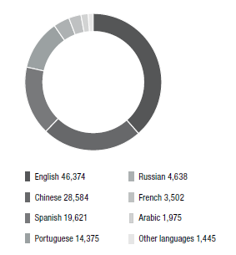
14. The online course DL-101 “General course on Intellectual Property” is free of charge and has a module about the Hague System. The course is available in the six United Nations languages (Arabic, Chinese, English, French, Russian and Spanish) as well as in Croatian, Georgian, Korean, Portuguese, Thai and Vietnamese. In terms of users in 2018, the course was taken by 33 per cent in English, 22 per cent in Portuguese, 22 per cent in Spanish,
11 per cent in Chinese, 4.5 per cent in Russian, 2.3 per cent in French, two per cent in Arabic, two per cent in Korean and one per cent in the other remaining languages.
15. The online course DL-302 “Trademarks, Industrial Designs and Geographical Indications” is an advanced course and available in the six United Nations languages (Arabic, Chinese, English, French, Russian and Spanish) as well as in Portuguese and Vietnamese. In terms of users in 2018, the course was taken by 43 per cent in Chinese, 24 per cent in English,
10 per cent in French, eight per cent in Russian, seven per cent in Spanish, five per cent in Portuguese, around 2.5 per cent in Arabic and less than one per cent in Vietnamese.
III. The change of the filing activIties after the addition of languages in the hague and pct systems
16. New languages have been introduced into the WIPO services gradually, which may affect the filing activities among the different available languages. The language shares under the Hague and PCT Systems during the past ten years are provided as below. The language shares under the Madrid System are not included as the Madrid System has the same language regime as the Hague System.

THE HAGUE SYSTEM
17. The Hague System was initially operated in French only. English was introduced in 1984 and Spanish in 2010. Since then, the only Contracting Party that joined the Hague System and whose official language is Spanish was Mexico.
18. The number of international applications filed in Spanish in the period from 2010 to 2019 consistently made up around one per cent of all international applications filed, since the introduction of Spanish into the Hague System.
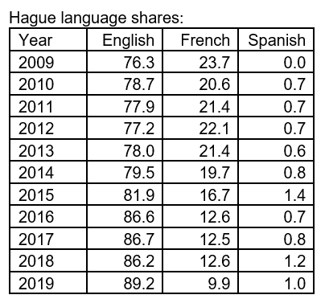

THE PCT SYSTEM
19. The PCT System started in 1970 with five publication languages, namely, English, French, German, Japanese and Russian. Subsequently, Spanish (in 1985), Chinese (in 1994),
Arabic (in 2006), Korean and Portuguese (both in 2009) were added.
20. The vast majority of PCT applications are published in the language in which they were filed. In 2019, 44.7 per cent of all PCT applications were published in English, followed by Japanese (19.7 per cent) and Chinese (19 per cent). The seven remaining languages of publication, combined, accounted for 16.6 per cent of the total. Whereas the combined share of the top three languages has remained relatively stable between 2013 and 2019, their respective contributions have changed drastically. While the use of Japanese has not changed much during this period, back in 2013, a majority of applications were published in English, and Chinese accounted for a low share in comparison.
21. Over the last 10 years, the shares in Spanish, Russian, Portuguese and Arabic remained stable under one per cent. The shares in German and French slightly decreased over the last 10 years to seven and two per cent, respectively. The shares in Korean slightly increased to almost six per cent since the introduction of Korean into the PCT System in 2009, while the share in Chinese increased from three per cent to 19 per cent over the last 10 years. The shares in Japanese remained stable around 19 per cent over the last eight years. Unlike in the Madrid and the Hague System, the shares in English decreased from around 62 per cent to around 45 per cent. The decrease of the shares in English largely reflects from the increase of the shares in Chinese. That is to say that the actual number of international applications filed and published in English did not decrease, however the ratio changed due to the increase of other languages, in particular Chinese.
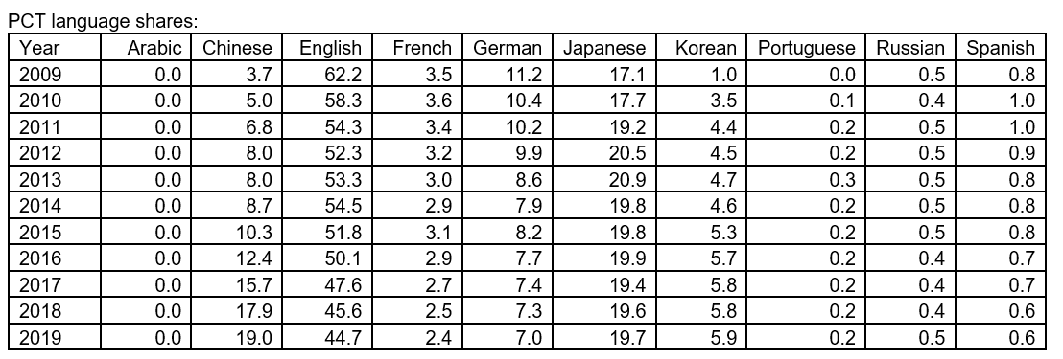
[End of Annex II and of document]

Refer to document H/LD/WG/8/8 “Summary by the Chair”, paragraph 30.
Refer to documents MM/A/42/1 and 4 and PCT/A/38/4 and 6, Annex III.
Those criteria include the number of speakers of a language (native and total) and the number of states per official language (total and member States).
Those criteria include the number of international applications and designs contained therein, the number of designs contained in applications filed abroad, and the official languages of the United Nations.
The origin of an application is defined as the country/territory of the address of the applicant. Applicants residing in a non-member country can file international applications if they have a real and effective industrial or commercial establishment within the jurisdiction of a Contracting Party of the Hague System.
The number of international application from applicants from the Democratic People's Republic of Korea was zero in 2019 (refer to Hague Yearly Review 2020).
Domestic design applications may be filed with the Swiss Federal Institute of Intellectual Property in German, French, Italian and Rhaeto-Romanic. According to the said Office, in 2018, around 71 per cent were filed in German, 24 per cent in French and 5 per cent in Italian.
Extracted from Hague Yearly Review 2020.
Extracted from Hague Yearly Review 2020.
For instance, the 1999 Act had thresholds for its entry into force (Article 28(2)).
Some jurisdictions have a single design application system, while others have a multiple design application system. Thus, the number of designs is used as opposed to the number of applications for this comparison.
Refer to the WIPO IP Statistics Data Center. The data for applications filed directly with national or regional IP Offices are only available up to 2018, as of the date of this document.
Refer to documents A/48/26, paragraph 250 and A/49/18, paragraphs 173 to 184.
In this regard, the International Bureau relied on the information contained in the visualcapitalist at www.visualcapitalist.com/100-most-spoken-languages/.
In this regard, the International Bureau relied on the information contained in the visualcapitalist at www.visualcapitalist.com/100-most-spoken-languages/.
Refer to the Concise Oxford Companion to the English Language, Ed. Tom McArthur, Oxford University Press, 2003.
In this regard, the International Bureau relied on the information contained in Wikipedia at Wikipedia.org and the Encyclopedia Britannica at www.britannica.com.
For the analysis of this criterion, the membership of the European Union and the African Intellectual Property Organization (OAPI) has been disregarded.
In this regard, the International Bureau relied on the information contained in Wikipedia at Wikipedia.org and the Encyclopedia Britannica at www.britannica.com.
According to document H/LD/WG/7/5 “Proposal by the Delegation of the Russian Federation”, Russian is a state language in three countries and an official language of one country.
Refer to Patent Cooperation Treaty Yearly Review 2020, page 71.
Refer to Article 39 of the WIPO Arbitration Rules, Article 33 of the WIPO Expedited Arbitration Rules, and Article 10 of the WIPO Mediation Rules at https://www.wipo.int/amc/en/rules/.
Refer to https://www.wipo.int/amc/en/center/caseload.html.
Refer to Article 11 of the Rules for Uniform Domain Name Dispute Resolution Policy at https://www.icann.org/resources/pages/udrp-rules-2015-03-11-en; refer also to https://www.wipo.int/amc/en/domains/search/overview3.0/#item45.
Refer to https://www.wipo.int/amc/en/domains/statistics/languages_yr.jsp?year.
Refer to https://www.wipo.int/hague/en/https://www.wipo.int/hague/en/.
Refer to https://www.wipo.int/hague/en/legal_texts.
WIPO Publication No. 911E/19. Refer to https://www.wipo.int/publications/en/details.jsp?id=4397.
Refer to the WIPO IP Portal at https://ipportal.wipo.int/.
Croatian, Georgian and Thai.
Refer to WIPO Academy Year in Review 2019.
In collaboration with member States, the WIPO Academy offers additional courses in those additional languages.
The Vietnamese versions of the DL-101 “General Course on IP” and DL-302 “Trademarks, Industrial Design and Geographical Indications” were under platform review by the Intellectual Property Office of Viet Nam between 2018 and 2019.
The course is run on a special platform in China.
At the same time as the 1960 Act entered into force.
Mexico joined the Hague System on June 6, 2020. Spain has been a Contracting Party to the 1999 Act since December 23, 2003.
Refer to table “Distribution of PCT applications by language of publication, 2005–2019” above.

