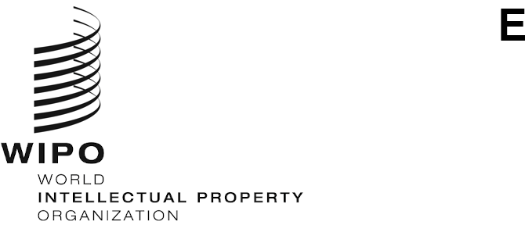
WO/CC/78/2
ORIGINAL: english
DATE: july 21, 2020

WIPO Coordination Committee
Seventy-Eighth (51st Ordinary) Session
Geneva, September 21 to 29, 2020
designation of the chair and deputy chair of the wipo appeal board
Document prepared by the Director General

INTRODUCTION
- The purpose of this document is to propose to the WIPO Coordination Committee Ms. Joan Powers (United States of America) and Mr. Pierre Panchaud (Switzerland) for designation as Chair and Deputy Chair, respectively, of the WIPO Appeal Board, with effect from October 12, 2020.

background
- The WIPO Appeal Board is an administrative body with staff participation, established by the Director General to advise him or her whenever a staff member, a former staff member or a duly qualified beneficiary to the rights of a deceased staff member, appeals against a decision taken under Staff Regulation 11.4 (“Formal Conflict Resolution”), or a disciplinary decision taken under Staff Rule 10.1.2.
- Pursuant to Staff Rule 11.5.1, the Chair and Deputy Chair of the WIPO Appeal Board are designated by the WIPO Coordination Committee, for a term of five years, on a proposal made by the Director General after consultation with the Staff Council.
- With effect from October 12, 2015, the WIPO Coordination Committee designated Mr. Norbert Wülher as Chair of the WIPO Appeal Board and Mr. Michael Bartolo as Deputy Chair. Their term of office will come to an end on October 11, 2020. While the term is renewable once, both of them indicated that they did not wish their appointments to be extended.

Selection process
- In January 2020, the Director General established a selection panel composed of three members of the Senior Management Team, namely, the Assistant Director General for the Administration and Management Sector, the Director of the Human Resources Management Department and the Legal Counsel, to conduct the selection process for the new Chair and Deputy Chair of the WIPO Appeal Board.
- The terms of reference for the individual contractor positions of Chair and Deputy Chair were advertised on WIPO recruitment page on January 30, 2020, with a deadline for application of February 20, 2020.
- Pursuant to Staff Rule 11.5.1(b)(1), the Chair and Deputy Chair of the WIPO Appeal Board must have “experience in the law of the international civil service or equivalent experience in applicable administrative law” and must “not [be] staff members or former staff members for the past 10 years of the International Bureau”. In addition, both the Chair and Deputy Chair must have excellent knowledge of written and spoken English, and either the Chair or Deputy Chair must also have excellent knowledge (written and spoken) of French.
- The selection process involved a written test, as well as interviews. The written test was aimed at assessing the candidates’ legal drafting skills and knowledge of the international civil service law.
- The proposed candidates were selected based on the outcome of the written test and interviews, and taking into account the language requirements for the two positions.
- In accordance with Staff Rule 11.5.1(b)(1), the Staff Council was consulted on the two candidates who are proposed to the WIPO Coordination Committee in the present document. The Staff Council was also provided with detailed information on the selection process and on the other candidates. The Staff Council submitted observations thereon and did not oppose the proposal.

proposed candidates
Ms. Joan Powers
- Ms. Joan Powers is an American national. She joined the International Monetary Fund (IMF) in 1984 as a Legal Counsel and held the position of Assistant General Counsel from 1996 to 2009, when she voluntarily separated from the IMF. Since then, she has undertaken a variety of consulting assignments with different international organizations and published several articles on international administrative law. For the past two years, she has also served as Chair of the Appeals Commission of the International Federation of the Red Cross and Red Crescent Societies in Geneva.
- Ms. Powers holds a Juris Doctor from the University of Pennsylvania Law School and a Bachelor’s degree in American history from the Brown University.
- Her mother tongue is English and she has basic knowledge of French.
Mr. Pierre Panchaud
- Mr. Pierre Panchaud is a Swiss national. He joined the Bank for International Settlements in 1988 as a Legal Counsel and held the position of Deputy General Counsel for two years until he took early retirement in November 2019. Since 2013, he has been teaching a Master’s degree course at the Law Faculty of the University of Basel.
- Mr. Panchaud holds a Master of Law from the University of Lausanne.
- His mother tongue is French and he is fluent in English.
- The WIPO Coordination Committee is invited to designate, for a term of five years as from October 12, 2020:
- Ms. Joan Powers as Chair of the WIPO Appeal Board, and
- Mr. Pierre Panchaud as Deputy Chair of the WIPO Appeal Board.
[End of document]

See Staff Regulation 11.5.
See documents WO/CC/71/5 and WO/CC/71/7.

