E
A/56/INF/5
ORIGINAL: ENGLISH
DATE: JuLy 18, 2016

Assemblies of the Member States of WIPO

Fifty-Sixth Series of Meetings
Geneva, October 3 to 11, 2016

Status of ACCESSIONS TO TREATIES ADMINISTERED BY WIPO, AND CONSTITUTIONAL REFORM MATTERS

Document prepared by the Secretariat

The present document sets out the evolution of membership of treaties administered by the World Intellectual Property Organization (WIPO) from January 1, 1970 to July 18, 2016, as well as an update on constitutional reform matters.

Particular attention is drawn to the WIPO treaties which have been updated, either through the adoption of a new act or instrument (which requires accession), through a decision to freeze the application of an earlier Act, or through an amendment (which requires acceptance), as described in this document (see paragraphs 2, 3, 5, 6, 7 and 25 through 34). Contracting Parties concerned are respectfully invited to consider updating their membership, as applicable.

I. PARTIES TO TREATIES ADMINISTERED BY WIPO

Convention Establishing the World Intellectual Property Organization (1967)

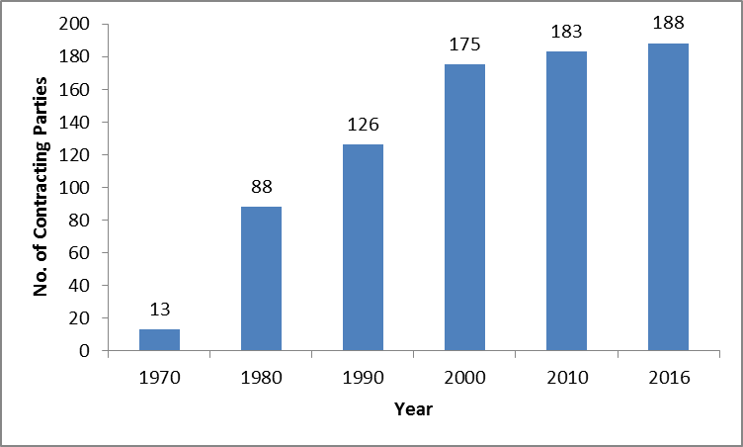

Paris Convention for the Protection of Industrial Property (1883)

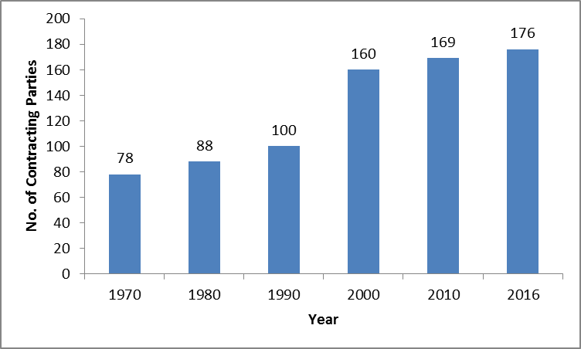

The Paris Convention for the Protection of Industrial Property (the Paris Convention) was revised several times since its conclusion in 1883. It was revised at Brussels (1900), Washington (1911), The Hague (1925), London (1934), Lisbon (1958) and Stockholm (1967), and amended in 1979.

For historical reasons, the Stockholm revision gave Member States the opportunity to accept only one part of the revision (Articles 1 to 12 which constitute the substantive provisions, or Articles 13 to 30 which constitute the final and administrative provisions) or accept one part earlier than the other.

Some Member States which have excluded the substantive provisions from their acceptance of the Stockholm Act, are still, to date, bound by the substantive provisions of an earlier Act, which do not reflect the most up-to-date thinking on matters covered by the Convention. The Member States concerned are Argentina, Bahamas, Lebanon, Malta, New Zealand, Philippines,
Sri Lanka, the United Republic of Tanzania and Zambia.

Some other Member States, namely the Dominican Republic and Nigeria, have never acceded to the Stockholm Act, but remain parties to an earlier Act. They are not members of the Assembly of the Paris Union, and thus are not able to participate in the decision-making organ of the Union.

The Member States concerned are respectfully invited to consider accession to the latest Act of the Convention or to accept all provisions thereof, as applicable.

Berne Convention for the Protection of Literary and Artistic Works (1886)

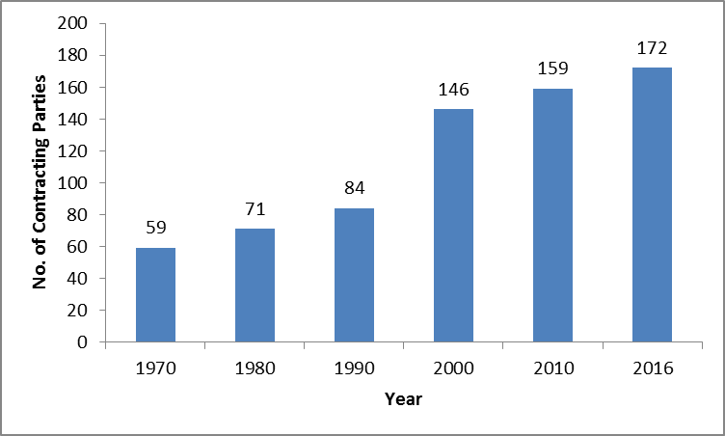

The Berne Convention for the Protection of Literary and Artistic Works (the Berne Convention) was revised several times since its conclusion in 1886. It was completed at Paris (1896), revised at Berlin (1908), completed at Berne (1914), revised at Rome (1928), at Brussels (1948), at Stockholm (1967) and at Paris (1971), and amended in 1979.

For historical reasons, the Stockholm and Paris revisions of the Convention also gave Member States the opportunity to accept only one part of the revision, namely to accept only the final and administrative provisions (Articles 22 to 38). There are still, to date, some States bound by the administrative provisions of the Paris Act only (and in some cases of the Stockholm Act) and not the substantive provisions thereof. The States concerned are Bahamas, Chad, Fiji, Malta, Pakistan, South Africa and Zimbabwe.

Some Member States on the other hand, not being members of either the Stockholm or Paris Acts, are not members of the Assembly of the Berne Union and therefore are not able to participate in the decision-making organ of the Union. Lebanon, Madagascar and New Zealand fall under this category.

The countries concerned are respectfully invited to accede to the latest Act of the Berne Convention or to accept all provisions thereof, as applicable.

Madrid Agreement for the Repression of False or Deceptive Indications of Source on Goods (1891)

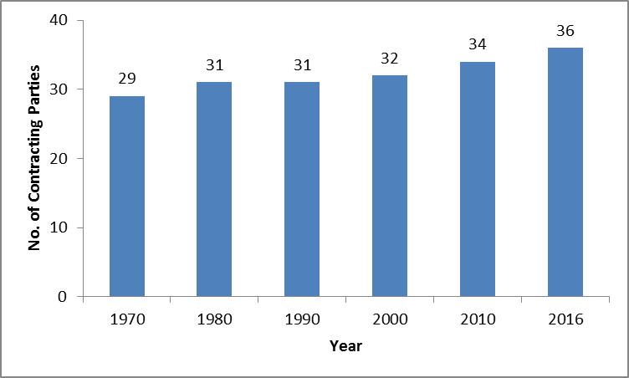

Madrid Agreement Concerning the International Registration of Marks (1891) and Protocol
Relating to the Madrid Agreement (1989)

The Madrid system is constituted by two Treaties, namely the Madrid Agreement Concerning the International Registration of Marks and the Protocol Relating to the Madrid Agreement (Protocol). However, with the entry into force, on October 31, 2015, of the Madrid Protocol with respect to Algeria, the Madrid system is, de facto a one-treaty system with the only applicable Treaty being the Protocol. Under a one-treaty system, accessions to the Agreement alone have become devoid of operational justification. Non-Madrid Union members are therefore respectfully invited to accede only to the Protocol.

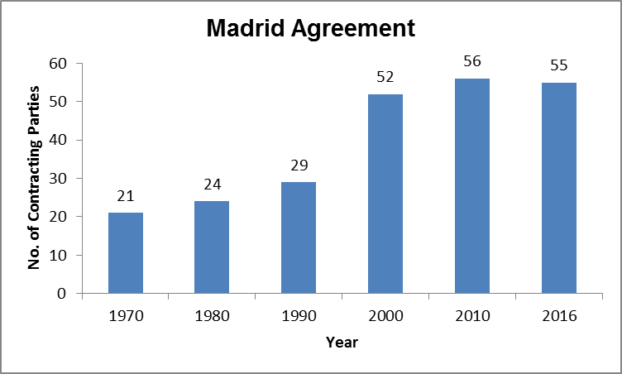

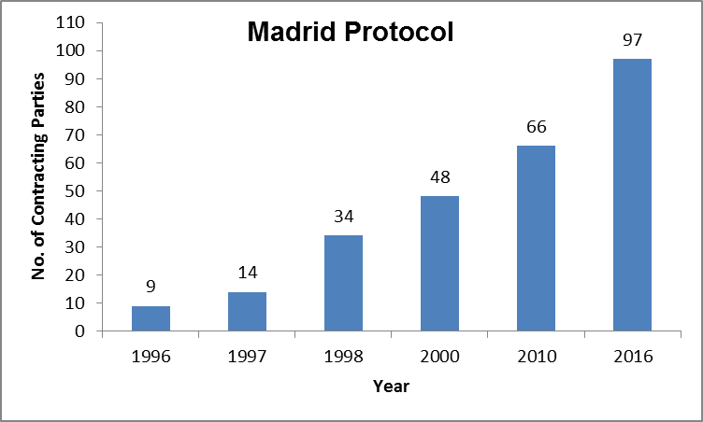

Hague Agreement Concerning the International Registration of Industrial Designs

The Hague Agreement concerning the International Registration of Industrial Designs is constituted by three Acts, namely the London (1934) Act, the Hague (1960) Act and the
Geneva (1999) Act.

As a first step towards a simplification of the Hague system, the 15 Contracting Parties to the 1934 Act decided, on September 24, 2009, to freeze the application of the 1934 Act. These States also agreed that the final aim would be the termination of the 1934 Act.

The Director General of WIPO received, on July 18, 2016, the last required consent to the termination of the 1934 Act, namely the consent from Egypt. It is recalled that 12 Contracting Parties to the 1934 Act have expressed their respective consent to its termination and three have denounced it. The termination of the 1934 Act will become effective on October 18, 2016.

To date, 65 States or intergovernmental organizations are members of the Hague Union, 51 of which are bound by the 1999 Act and 34 of which are bound by the 1960 Act. The two charts below provide information as to the evolution of The Hague Union membership.

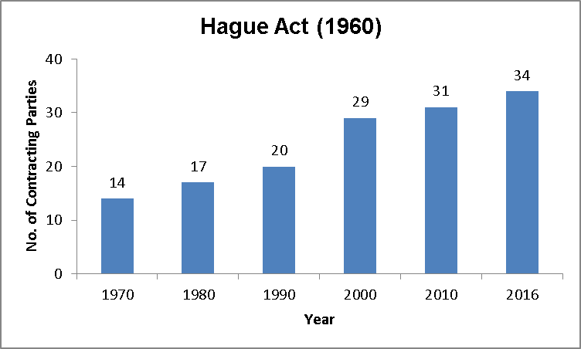

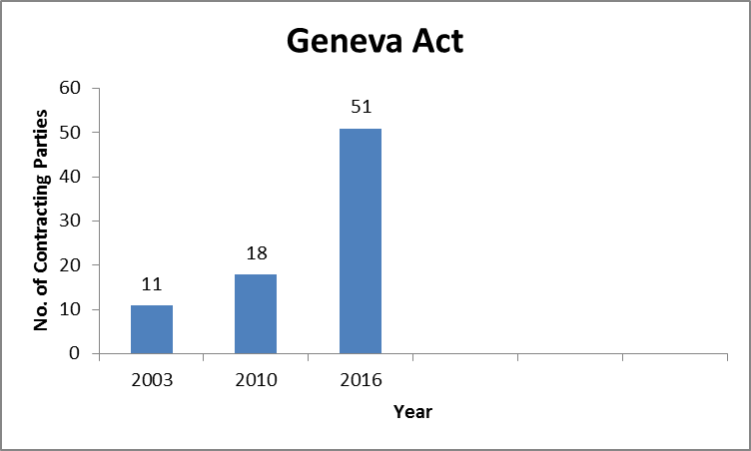

Nice Agreement Concerning the International Classification of Goods and Services for the
Purposes of the Registration of Marks (1957)

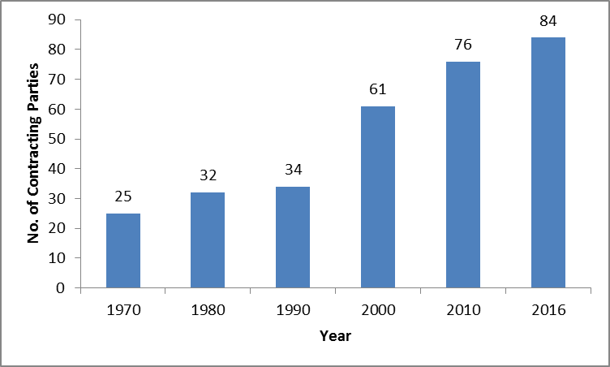

The Nice Agreement was revised twice after its adoption in 1957, namely at Stockholm (1967) and at Geneva (1977). Some Member States remain bound by the Stockholm Act, namely Algeria, Israel and Morocco, and two States by the original Nice Agreement, namely Lebanon and Tunisia (which are therefore not members of the Assembly). These States are respectfully invited to consider acceding to the Geneva Act of the Nice Agreement.

Lisbon Agreement for the Protection of Appellations of Origin and their International
Registration (1958)

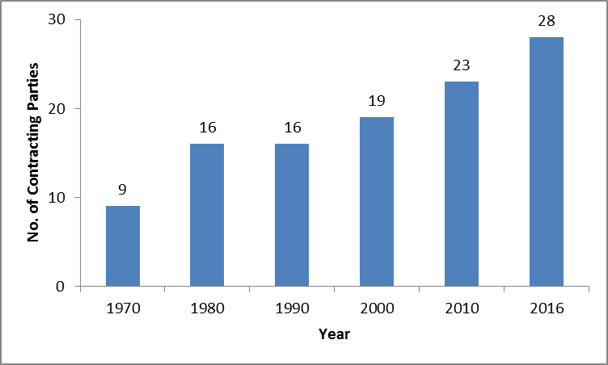

The Lisbon Agreement, adopted in 1958, was revised in Stockholm in 1967, and amended

in 1979. The same invitation as applies to the other treaties is extended to Haiti, which is not bound by the Stockholm Act of the Lisbon Agreement and, therefore, is not a member of the Lisbon Assembly.

The Diplomatic Conference for the Adoption of a New Act of the Lisbon Agreement for the Protection of Appellations of Origin and their International Registration adopted, on May 20, 2015, the Geneva Act of the Lisbon Agreement on Appellations of Origin and Geographical Indications. The said Act was opened for signature on May 21, 2015. To date, 15 States have signed the Geneva Act, but no State has acceded to it. This Act shall enter into force three months after five eligible parties have deposited their instruments of ratification or accession.

9. International Convention for the Protection of Producers of Performers, Producers of
Phonograms and Broadcasting Organisations (1961)

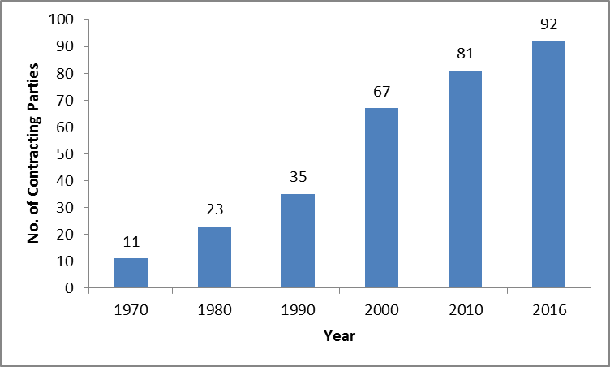

10. Locarno Agreement Establishing an International Classification for Industrial
Designs (1968)

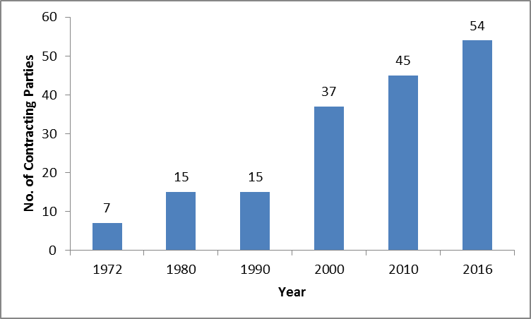

11. Patent Cooperation Treaty (PCT) (1970)

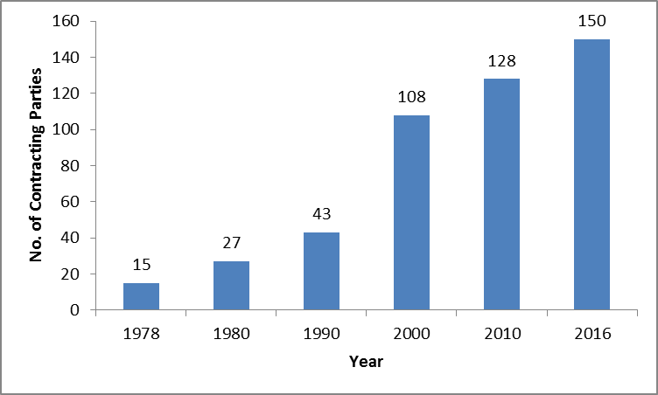

12. Strasbourg Agreement Concerning the International Patent Classification (1971)

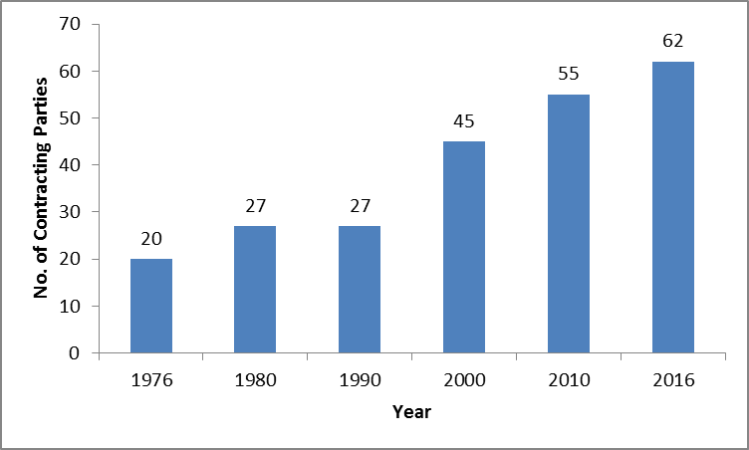

13. Convention for the Protection of Producers of Phonograms Against Unauthorized Publication of their Phonograms (1971)

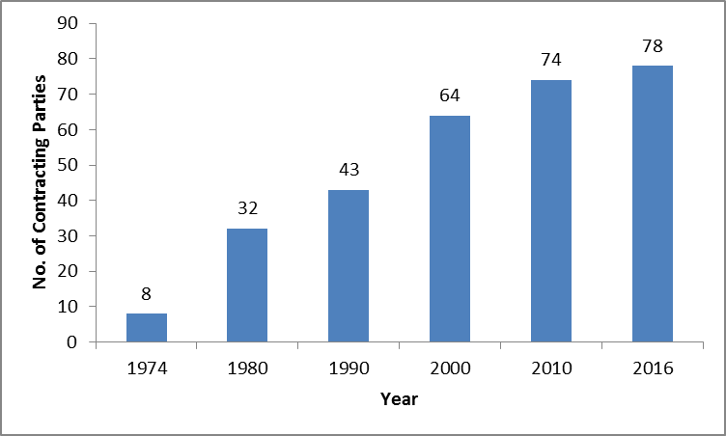

14. Vienna Agreement Establishing an International Classification of the Figurative Elements of Marks (1973)

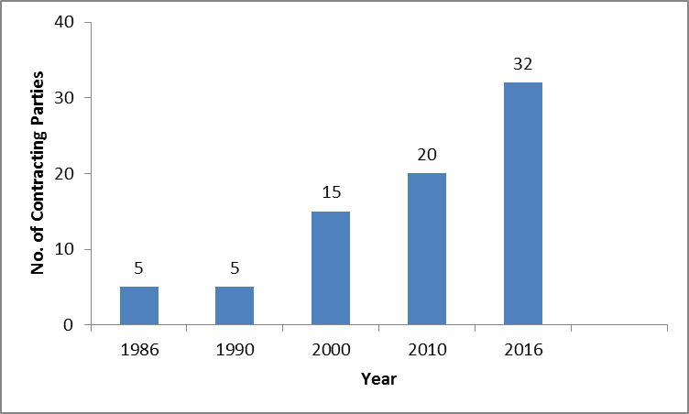

15. Convention Relating to the Distribution of Programme-Carrying Signals Transmitted by Satellite (1974)

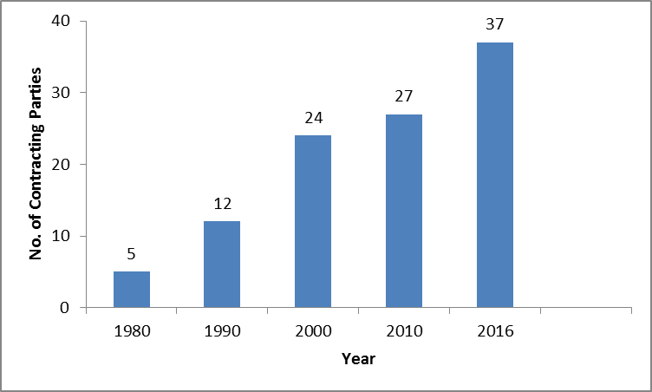

16. Budapest Treaty on the International Recognition of the Deposit of Microorganisms for the
Purposes of Patent Procedure (1977)

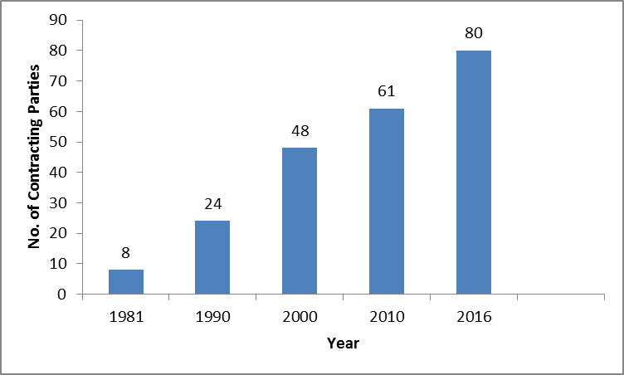

17. Nairobi Treaty on the Protection of the Olympic Symbol (1981)

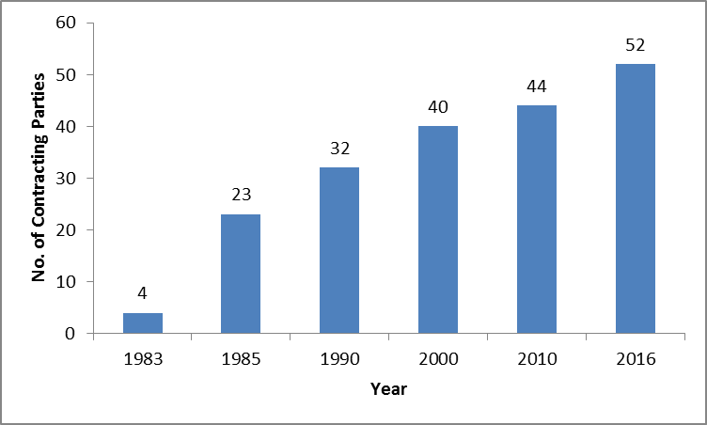

18. Trademark Law Treaty (TLT) (1994)

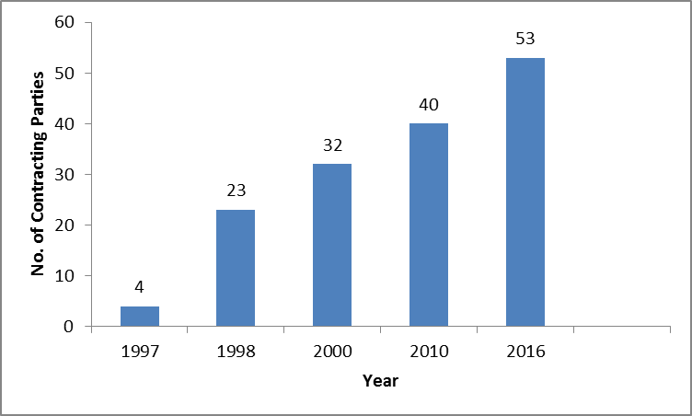

19. WIPO Copyright Treaty (WCT) (1996)

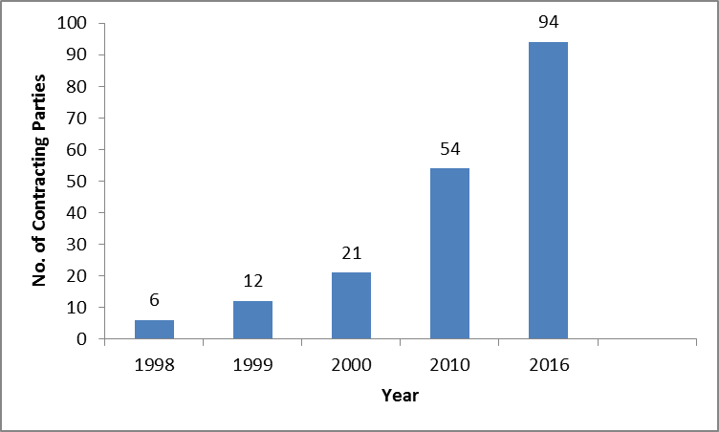

20. WIPO Performances and Phonograms Treaty (WPPT) (1996)

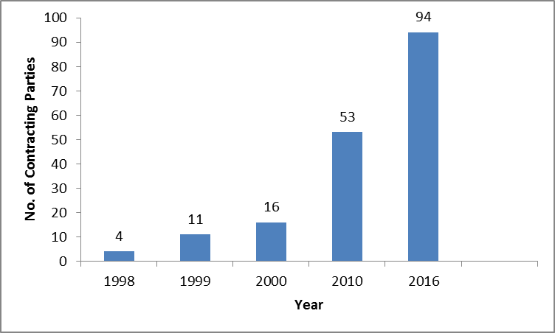

21. Patent Law Treaty (PLT) (2000)

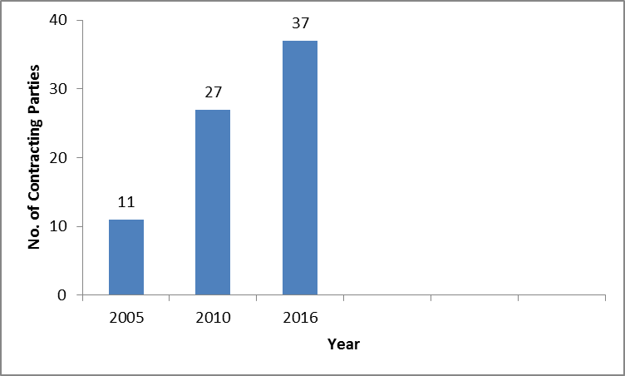

22. Singapore Treaty on the Law of Trademarks (2006)

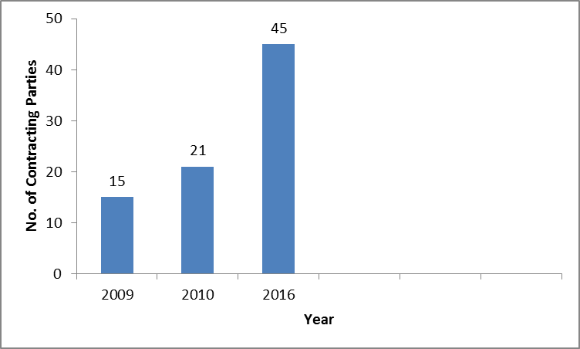

23. Marrakesh Treaty to Facilitate Access to Published Works for Persons who are Blind, Visually Impaired or Otherwise Print Disabled (2013)

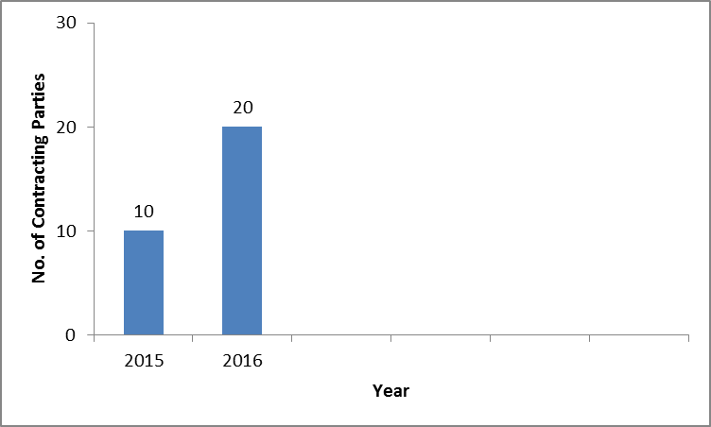

The last required instrument of accession or ratification for the entry into force of the Marrakesh Treaty was deposited on June 30, 2016 by Canada. The Marrakesh Treaty will enter into force on September 30, 2016.

24. Beijing Treaty on Audiovisual Performances (2012)
(Not yet in force. 30 eligible accessions/ratifications needed for entry into force).

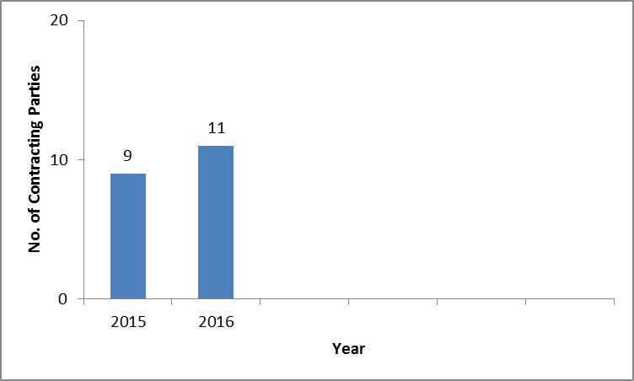

II. Constitutional Reform

25. At their meeting in September 2002, the Assemblies of the Member States of WIPO adopted the three recommendations submitted to them by the WIPO Working Group on Constitutional Reform. The three recommendations are: (i) the abolition of the WIPO Conference; (ii) the formalization in the treaties of the unitary contribution system and the
changes in contribution classes that have been practiced since 1994; and (iii) a change in the periodicity of the ordinary sessions of the WIPO General Assembly and the other Assemblies of the Unions administered by WIPO, from once every two years to once every year
(document A/37/14, paragraphs 291 to 301).

26. In order to implement the decision of the Assemblies in respect of the three recommendations mentioned in the preceding paragraph, several of the treaties administered by WIPO needed to be amended. Therefore, the WIPO Conference and the competent Assemblies of certain Unions administered by WIPO unanimously adopted on October 1, 2003, amendments to the WIPO Convention, as well as to other WIPO-administered treaties, namely the Paris Convention for the Protection of Industrial Property (the Paris Convention), the Berne Convention for the Protection of Literary and Artistic Works (the Berne Convention), the Madrid Agreement Concerning the International Registration of Marks (the Madrid Agreement), the Hague Agreement Concerning the International Deposit of Industrial Designs (the Hague Agreement), the Nice Agreement Concerning the International Classification of Goods and Services for the Purposes of Registration of Marks (the Nice Agreement), the Lisbon Agreement for the Protection of Appellations of Origin and their International Registration (the Lisbon Agreement), the Locarno Agreement Establishing an International Classification for Industrial Designs (the Locarno Agreement), the Patent Cooperation Treaty (PCT), the Strasbourg Agreement Concerning the International Patent Classification (the Strasbourg Agreement), the Vienna Agreement Establishing an International Classification of the Figurative Elements of Marks (the Vienna Agreement) and the Budapest Treaty on the International Recognition of the Deposit of Microorganisms for the Purposes of Patent Procedure (the Budapest Treaty) (document A/39/15, paragraphs 166 and 167).

27. In accordance with the relevant provisions of the WIPO-administered treaties, the said amendments will enter into force one month after written notifications of acceptance, effected in accordance with their respective constitutional processes, have been received by the Director General of WIPO from three-fourths of the States Members of WIPO and/or the relevant Assemblies at the time the Conference and the competent Assemblies adopted the amendments.

28. As of July 18, 2016, 15 notifications of acceptance have been received, out of the 135 notifications of acceptance required for the entry into force of the amendments described in the preceding paragraphs.

III. Number of Mandates of Directors General

29. The WIPO General Assembly, at its twenty-third (10th extraordinary) session from September 7 to 15, 1998, acting upon the recommendation of the WIPO Coordination Committee, adopted a policy that limits the number of mandates of Directors General to two fixed terms of six years each, and decided that the WIPO Convention should be amended accordingly (document WO/GA/23/7, paragraph 22).

30. Subsequently, the Assemblies of the Paris and Berne Unions, respectively, and the WIPO Conference unanimously adopted on September 24, 1999, an amendment to Article 9(3) of the WIPO Convention, as described below (document A/34/16, paragraph 148).

31. The present text of Article 9(3) of the WIPO Convention provides as follows:

“The Director General shall be appointed for a fixed term, which shall be not less than six years. He shall be eligible for reappointment for fixed terms. The periods of the initial appointment and possible subsequent appointments, as well as all other conditions of the appointment, shall be fixed by the General Assembly.”

32. The text of the adopted amendment to Article 9(3) reads as follows:

“The Director General shall be appointed for a fixed term of six years. He shall be eligible for reappointment only for one further fixed term of six years. All other conditions of the appointment shall be fixed by the General Assembly.”

33. In accordance with Article 17(3) of the WIPO Convention, the said amendment will enter into force one month after written notifications of acceptance, effected in accordance with their respective constitutional processes, have been received by the Director General of WIPO from three-fourths of the States Members of WIPO at the time the Conference adopted the amendment.

34. As of July 18, 2016, 52 notifications of acceptance have been received by the Director General, out of the 129 notifications of acceptance required for the entry into force of the amendment described in the preceding paragraphs.

35. Member States are respectfully invited to transmit their instruments of acceptance of the amendments to the WIPO Treaties described above.

[End of document]

These are the Paris Convention for the Protection of Industrial Property, the Berne Convention for the Protection of Literary and Artistic Works, the Nice Agreement Concerning the International Classification of Goods and Services for the Purposes of the Registration of Marks and the Lisbon Agreement for the Protection of Appellations of Origin and their International Registration as concerns its Stockholm Act of 1967.
The London Act (1934) of the Hague Agreement Concerning the International Registration of Industrial Designs.
See Parts II and III on constitutional reform and number of mandates of Directors General.

