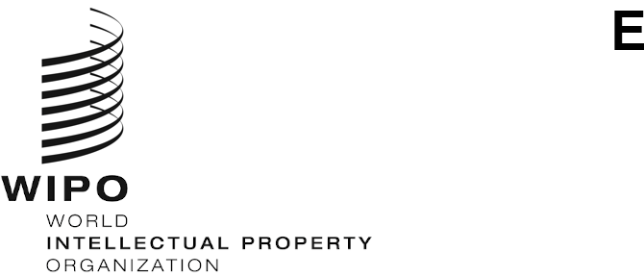
CDIP/31/INF/2
ORIGINAL: ENGLISH
DATE: SEPTEMBER 6, 2023

Committee on Development and Intellectual Property (CDIP)

Thirty-First Session
Geneva, November 27 to December 1, 2023

EXECUTIVE SUMMARY OF THE WIPO TOOL ENTITLED “DRAWING ON CREATIVITY, COPYRIGHT FOR ANIMATION INDUSTRY PROFESSIONALS: A TRAINING TOOL”
prepared by Rob H. Aft
The Annex to this document contains the Executive Summary of the WIPO tool entitled “Drawing on Creativity, Copyright for Animation Industry Professionals: A Training Tool”.
This tool has been undertaken in the context of the Development Agenda (DA) Project on “Promoting the Use of Intellectual Property in Creative Industries in the Digital Era in Chile, Indonesia, the United Arab Emirates and Uruguay” (document CDIP/26/5). It was prepared by Mr. Rob H. Aft, President of Compliance Consulting, in Los Angeles, California, The United States of America.
The Committee is invited to take note of the information contained in the Annex to the present document.
[Annex follows]

DRAWING ON CREATIVITY

Copyright for Animation Industry Professionals: A Training Tool

Executive Summary
“Animation offers a medium of storytelling and visual entertainment which can bring pleasure and information to people of all ages everywhere in the world.”
- Walt Disney
When Walt Disney wrote those words, animation involved hundreds of his employees, mostly women, drawing and painting thousands of pictures by hand, laboriously recording dialogue, and often hiring full orchestras to play the music. Distribution meant showing a 35mm print in a cinema. It was hugely costly, and there were very few places where the work could be done. Screenwriters, character developers, artists, musicians, and voice-over talent were contracted to provide creative services on a work-for-hire basis, retaining no control or financial interest in their work. Since then, the animation industry progressed both technically and legally, allowing creators to retain more control of their work, as long as they adhered to the local laws of the 181 signatories to the Berne Convention for the Protection of Literary and Artistic Works.

ANIMATION IS AN INTELLECTUAL PROPERTY BUSINESS
This tool introduces the novice animation stakeholder to the production, legal and business-related issues for participation in the now well-structured global marketplace for animated films, TV programs, online, and educational content. Copyright is fundamental for all these issues with an emphasis on its standards and principles currently observed and practiced in the animation industry at the international level. Readers should consult local industry experts to gain a complete understanding of these issues in their respective countries.
Understanding and applying business concepts, ethics reliability are key for professional recognition in the animation industry. That includes adhering to local laws related to the establishment of companies, taxes, employment, transfer of copyright, financial transactions and, perhaps most importantly, local customs pertaining to the conduct of respectable businesspeople. Such respectability includes keeping proper accounting, promptly paying bills, and helping to strengthen the animation community through education, government involvement and using similar techniques of other industries to gain respect as important players in the national economy.
Legal and contractual practices vary across jurisdictions, with lawyers’ involvement and written agreements being the norm in some, and personal relationships and oral agreements common in others. Regardless, all copyright transactions must be in written form to be valid. Government subsidies and support are available in some; and in others, there is no such assistance at all. Distribution, production budgets, export potential, and many other local factors must be considered when applying the lessons in this tool.

ANIMATION IS A POPULAR AND INCREASINGLY COST-EFFECTIVE CONTENT CREATION METHOD
The sharp decline in the technical cost of creating animation put the medium in the hands of anyone with a cell phone or computer. Simultaneously, rising distribution opportunities created a global market for locally produced material. However, there is relatively little change in the real creative work – character design, scriptwriting, music composition, and voice acting. For most practitioners, the barrier to entry was never the creative work, but rather the cost of production and lack of distribution opportunities. Understanding ownership and licensing of rights to original works of authorship (which may or may not need to be fixed in a medium depending on the jurisdiction) is the first step in accessing the market whether in cinemas, on global streaming services, local broadcast TV or any other future technologies.
As costs decreased, many low to middle-income regions entered the animation industry, often with training and infrastructure support from their local governments. Training animators and technicians is vital to creating a copyright-based animation industry. Equally important is business and legal training to ensure sustainability. As demonstrated in Korea’s NEON profile in Annex III, many studios create content for both consumers and third parties. The same concepts apply, when a company is developing a consumer product (e.g. a children’s program or feature film, also referred to as business-to-consumer or B-to-C) or offering commercial services such as industrials, training videos, animated logos, or visual effects, to other businesses (B-to-B). The latter is usually provided on a “work-for-hire” basis, whereby copyright is retained by the hiring company instead of the studio, artist or technician.

PRACTICAL CONSIDERATIONS
This tool explores the basic structure of the animation industry including opportunities for creators; what copyright is created by the producer of a work; how copyright is recorded and licensed to third parties; and how value is created in the original work, as well as in derivative and ancillary works like merchandise, sequels, stage shows and other works using the characters and storylines. The tool also looks at the rights that a producer must secure to claim copyright ownership of the script, characters, music, and voice/motion capture performances. Finally, the tool analyzes the business of animation and how to deal with challenges while building a sustainable intellectual property (IP) based business.
As a broad term, “animation” can include non-narrative forms, such as animated logos, visual effects, video games, news/sports graphics, and be used to provide visual enhancement to a program or event. The latter encompasses rare cases involving the creation of copyrighted material and are therefore not covered in this tool. Nevertheless, they can generate additional income streams for animation studios, artists, and technicians.
This tool aims to support the growth of animation industries around the world, encourage local creative communities to develop sustainable businesses in a growing sector of the IP industry.
Full version of the tool is available at:
http://www-dev.wipo.int/edocs/mdocs/mdocs/en/wipo_cr_jkt_23/wipo_cr_jkt_23_www_615978.pdf
[End of Annex and of document]

